EVALUATING SUITABLE LOCATIONS FOR THE DEVELOPMENT AND PRESERVATIONS OF AFFORDABLE HOUSING IN FLORIDA: THE AHS MODEL

Wang, Ruoniu, wrnvince@ufl.edu
Blanco, Andres G agblanco@ufl.edu
Kim, Jeongseob seobi78@ufl.edu
Chung, Hyungchul lycrak08@ufl.edu
Ray, Anne L aray@ufl.edu
Arafat, Abdulnaser naserarafat@dcp.ufl.edu
O’Dell, William billo@ufl.edu
Thompson, Elizabeth liz.thompson@dcp.ufl.edu

Abstract
This paper discusses the potential uses of suitability tools for affordable housing policy by evaluating the assisted stock in Orange County, Florida through the Affordable Housing Suitability (AHS) model. The results show that properties that have received assistance since the 1960s have better suitability conditions than the average of parcel in the county. However, there are some trade-offs between different priorities of public policy such as conflicts between accessibility and socio-economic conditions. This is related to the process of urbanization in a sprawling metropolis in which suburbanization has been coupled with city center decline. In addition, there are also indications that properties that have left the assisted stock present better suitability conditions than those that stayed, implying that improving the locations for subsidized housing needs to consider the preservation dimension in the long term. In general, the analysis suggests that the process of decision making about siting could benefit by the use of tools that allow the spatial analysis of multidimensional and conflicting priorities since they can provide not only a way to visualize information but also to effectively process big amounts of information, identify trade-offs, and experiment with different policy scenarios.

- INTRODUCTION
In spite of the decline of housing prices produced by the current market crisis, housing affordability continues to be an issue in many cities of the United States with nearly one in four working households spending more than half of their income on housing costs. In Florida, one of the centers of the market burst, the percentage of severely housing cost burden households reached 33% in 2009, one of the highest in the nation, as incomes decreased faster than housing costs. At the same time, policies to provide affordable housing are struggling. For instance, more than 50,000 subsidized units have been lost in Florida as owners opt-out from contracts or fail to maintain properties according to the required standards (Shimberg Center, 2010).
Under these conditions, the identification and evaluation of suitable sites for the development and preservation of affordable housing acquires renovated relevance. A good site cannot only affect the quality of life for residents by providing more access to opportunities but also can increase the sustainability of the housing solution by helping public officials to design specific and localized policies to maintain and preserve affordable housing.
This paper describes the process of development of the Florida Affordable Housing Suitability Model (AHS), a Geographic Information Systems (GIS)-based decision tool to assess optimum locations for the development and preservation of low-income housing. Based on theoretical and empirical studies the model combines several locational determinants including physical infrastructure and environmental quality, social characteristics at the level of the neighborhood, local accessibility to social services, rental housing costs, driving costs and transit accessibility.
The model prioritizes characteristics based on input from local planners, housing experts, and the community. Maps show where positive attributes overlap and conflicting characteristics coincide. For example, it can show transit-accessible areas that have low poverty rates and crime, as well as areas that are transit-accessible but struggle with poverty, or poor air and soil quality. Moreover, the AHS has the ability to identify locations at scales from individual sites to regional development areas.
In addition, the model can function as an evaluation tool by assigning scores to sites for each location determinant allowing comparisons and identification of trade-offs. In this paper, we use the AHS to evaluate the sites of properties that have been part of the assisted housing inventory in Orange County, Florida. This county is the central area of the Orlando MSA, the fastest growing urban area in the state.
In the next section, we describe the AHS model in depth starting with a brief summary of the basics of suitability analysis. The section also includes the presentation of the structure and elements of the model and their justification. Then, we describe the process of analysis of the assisted housing inventory using the AHS giving special emphasis to comparisons for every location determinant in terms of type of programs, decade of initial funding, and current status of the properties. Finally, we conclude with a discussion of the possibilities for future research and some policy recommendations.

- THE AHS MODEL

  - Suitability analysis
Suitability analysis is typically defined as “the process of determining the fitness, or the appropriateness, of a given tract of land for a specified use” (Steiner, 1983). The basic premise of suitability analysis is that this ‘fitness’ depend on the combination of different determinants that are represented on individual maps that are then overlaid. While each layer provides key information, visualizing their synthesis through the superimposition allowed by suitability analysis produces entirely new knowledge that is difficult to figure out just by analyzing each individual factor.
Land suitability has a long tradition. It started more than a hundred years ago with landscape architects like Charles Eliot and Warren Manning overlaying hand-drawn sieve maps to see how different combinations of factors were represented in space (Steinitz, Parker, & Jordan, 1976). Ian McHarg’s ‘Design with Nature’ advanced on the idea by superimposing maps of diverse social variables represented in different color scales (McHarg, 1969). But it was the introduction of specialized software in the late 1960s what definitively popularized land suitability since the data storage and processing capabilities of computers allowed the representation and combination of a wide variety of variables.
Today, GIS-based land-use suitability has become more accessible to planners and the general public. It has been used for several different objectives such as determining habitat suitability (Pereira & Duckstein, 1993; Store & Kangas, 2001), prioritizing land conservation efforts, (Miller, Collins, Steiner, & Cook, 1998; Trust for Public Land, 2005), defining public facility siting (Higgs, 2006), and planning sustainable residential development (Sorrentino, Meenar, & Flamm, 2008).
In terms of analysis for housing affordability, suitability has been used to assess factors like topography, soil type, probability of flooding, proximity to infrastructure and transportation networks, and land use compatibility (Al-Shalabi et al., 2006; Thomson & Hardin, 2000). Other analyses have included social dimensions such as access to employment and other local resources that are critical to lower income households (Hartman, 1998).
In this regard, the technique has been applied to different contexts and questions like the location of low income housing in Johannesburg (Biermann, 1999); the identification of areas zoned for housing with good access to neighborhood services in Worchester, MA (Hamir et al, 2003); the definition of areas for development closer to urban cores to avoid sprawl in two counties in Delaware (Svatos and Doucette, 2003); the determination of suitable parcels for mixed income developments in three neighborhoods in Chicago (Hester and Radford, 2005), and the combination of location factors related to the supply and demand for housing to prioritize public policies in South Africa (CSIR, 2005).

  - The AHS structure
In the AHS model, each map layer represents factors deemed to be important for the location of affordable housing. The model is organized in four major components: residential suitability, rental housing costs, driving costs, and transit accessibility. Each component is assigned a score between 0 and 25 where: 0 is not suitable and 25 is highly suitable. The scores reflect relationships among a set of spatial characteristics. It is important to note that the relationships are relative to local conditions, there are no thresholds or benchmarks in the model. This guarantees the applicability of the model to different cases and avoids sharp typing points that can mask important dynamics. Figure 1 represents the basic structure of the model.
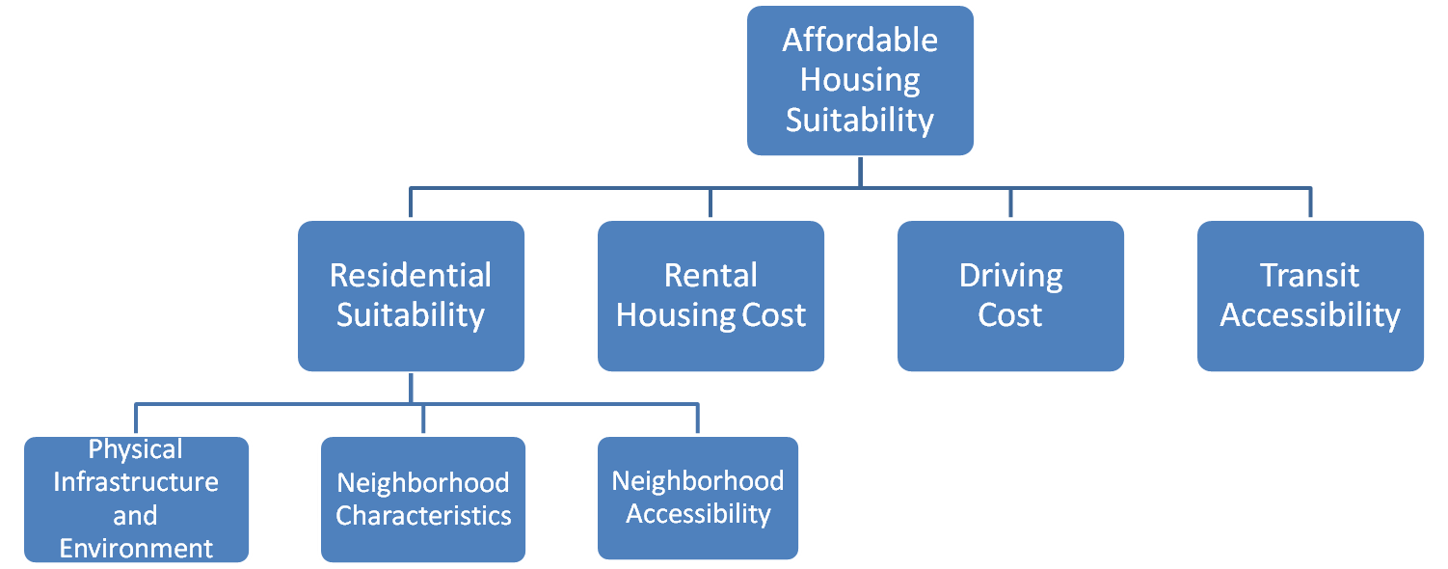
Figure 1 Basic Structure of the AHS Model

As shown in figure 1, the first component, residential suitability, is composed by three sub-components: physical infrastructure and environment, neighborhood characteristics, and neighborhood accessibility. The subcomponent of physical infrastructure and environment includes variables related to soils (corrosivity, shrink-swell potential, etc), ambient (noise areas, noxious odors, and respiratory dangers), and hazards and incompatibilities (flood zones, superfund sites, and conservation lands). Locating residential uses near these factors can have negative consequences for residents and the environment so proximity to them will mean a lower suitability. In addition, this subcomponent includes access to infrastructure (water and sewer service areas). In this case more proximity will be good since it will represent lower costs for the municipality. Thus, areas with high suitability in this subcomponent will have better physical and environmental conditions for development.
The second subcomponent of residential suitability, neighborhood characteristics, includes variables representing how well the area fares in socio-economic terms. It is composed by factors like educational quality, poverty incidence, educational attainment, household income, and the rate of violent & property crimes. In this case, suitability will be higher in neighborhoods with better levels of education, higher incomes, and lower crime risks. The objective is to avoid the typical pattern of concentrating poverty that was characteristic of programs of public housing in the United States (Newman and Schnare, 1997). Deconcentrating affordable housing, and mixing it with middle- and high-income residences, is the best chance to break the negative reinforcing feedback associated with poverty traps.
The third subcomponent of residential of suitability, neighborhood accessibility, captures the proximity and opportunity to important facilities for everyday life such as transit stops, elementary schools, daycare, public safety (fire rescue and police stations), healthcare, recreation and retail. Proximity is operationalized as the distance to the nearest facility that can be traveled by biking and walking. Opportunity is a composite measure of the number and variety of the facilities accessible by these two modes of transportation from any given parcel. Locations near more and diverse neighborhood facilities will have a higher suitability score. The policy objective behind this subcomponent is to achieve well balanced urban systems in which low-income residents are not condemned to live in food, health, or education ‘deserts’ as different initiatives are trying to do now.
Apart from all these subcomponents of residential suitability, the model includes a component capturing the rental housing costs defined as the ratio of the block group gross rent to the block group household income. In this case, a higher ratio means a lower suitability. It is important to note that this second component is not opposite to the objective of deconcentrating poverty since it is capturing the relation of rents and income rather than only rents in absolute terms. Therefore, it is more a measure of affordability than a measure of the quality of the neighborhood. This consideration is important for the location of affordable housing since the assisted housing stock is at higher risk in areas where prices are increasing as owners opt out from contracts, pre pay subsidized mortgages, or fail to maintain the property adequately with the objective of converting the property to market rates or condominiums (Finkel et al, 2006; Khadduri and Wilkins, 2008; Shimberg Center, 2008). In this regard, this component is related to the sustainability of the affordability of the properties in the long run.
The third component, driving costs, is estimated by regressing trip data (including work, shopping, social and recreation, and other home- and non-home-based trips) as function of land use and urban form measurements such as density, land use mix, connectivity, network accessibility to employment, and other control variables. The objective is to use the coefficients of the regression to generate a surface representing the driving costs for any given area according to its land use and urban form variables. Areas with low driving costs will be considered more suitable following new measures of affordability that recognize that there is a trade-off between transportation expenditures and housing expenditures and that both need to be taken into account to really capture the financial burden associated with location decisions (CNT, 2010).
The fourth and last component, transit accessibility, follows the same logic. It is operationalized considering the accessibility from transit stops to residential locations, the distance and time that would be spent in transit taking into account the routes and frequencies, and the accessibility from transit stops to employment opportunities. Therefore in this component higher scores will mean more accessibility to employment via transit.
The AHS model combines these variables, sub-components, and components assigning weights to each element using pair-wise comparisons according to the input provided by local planers, housing experts, and the community. Development of the model began in 2007 with a joint effort of the Shimberg Center for Housing Studies and the Department of Urban and Regional Planning at the University of Florida. Funding support was provided by the Wachovia Foundation (now a part of Wells Fargo). Initially, the AHS focused on the counties of Duval (Jacksonville MSA), Orange (Orlando MSA) and Pinellas (Tampa MSA) in Florida. The variables included in the model were selected based on an extensive literature review and the availability of data.
Most of the data were obtained from the Florida Geographic Data Library (FGDL) warehoused and maintained by the GeoPlan Center at the University of Florida. The original sources vary according to the variable but most come from the Florida Department of Revenue (FDOR) in the case of parcel data, Census and American Community Survey for socio-economic information, and National Housing Travel Survey for transportation. In other cases, notably transit and crime, specialists in the GIS departments of the pilot communities were able to provide detailed geo-coded information about local characteristics. Some data is specific for Florida like educational quality which is measured through the state standardized scores for schools. A complete list of the data sources, the process of operationalization and the literature review can be found in the final report for the portion of the research funded by the Wachovia Foundation (available upon request).

- ANALYSIS OF THE ASSISTED HOUSING INVENTORY IN ORANGE COUNTY USING THE AHS MODEL

  - Background
In this section, we analyze the Assisted Housing Inventory (AHI) using the AHS model. The AHI, defined as privately owned rental properties that receive public subsidies for complying with affordability restrictions, is one of the main sources for low-income households. In Florida, 2,250 assisted properties provide more than 250,000 affordable units. The assisted stock supplies more affordable units than the other two main policies of subsidized rental housing combined. Public housing, rental housing both publicly funded and publicly owned, provides 39,434 units. Housing Choice Vouchers, demand subsidies directed to households, provide 94,347 subsidies (Ray et al, 2009).
As noted, the AHI is facing strong pressures as owners retire properties from the assisted stock. The Shimberg Center maintains a complete dataset of this ‘Lost Properties Inventory’ (LPI) in Florida which shows that approximately 400 multifamily rental properties with 55,877 units that were subsidized by different federal, state or local programs are losing their assisted character and are at risk of becoming unaffordable in the state. This impacts negatively current efforts to expand the assisted stock. From 2004 to 2010, for instance, while 45,923 units were added to the stock, 30,617 units were lost.
This study assesses how subsidized housing fares in terms of the components of the AHS model using the case of Orange County in Florida. For the analysis each property in the AHI and the LPI in this county was assigned a score based on the average of the AHS result in an area defined by a radius of 400 meters from the property location. For this example all the variables and components in the model were equally weighted.
The first analysis compares all the properties that have had any type of assistance with the average for the parcels in the county with the objective to assess the general siting situation of assisted housing. In addition, properties that are currently in the AHI are compared with properties in the LPI to investigate if there are any particular location characteristics that are increasing the likehood of leaving the assisted inventory. Then, a comparison of the different programs of assistance is conducted to allow the evaluation of public policy decisions regarding the location of subsidized housing. Finally, we study the impacts of the decade of construction in the different components of the model.
  - Final score for the AHI and the LPI
Figure 2 shows the map of suitability for Orange County and the scores for the AHI and LPI properties discriminated by program. The green areas showing higher suitability are those within or nearby the municipality of Orlando, the central urban area in the county, where most residences, jobs and social services are located. This is not surprising since most of the variables included in the model represent an ‘urban premium’ in terms of suitability associated with higher accessibility. Other suitable areas correspond to the centers of other urbanized municipalities like Winter Garden and Apopka in the west and north-west or big concentrations of employment like the area of the south-west where Disney World is located. Low suitable areas are represented in red colors and correspond mainly to low density suburban or rural areas.
Figure 2: Final scores for the Assisted Housing Inventory (AHI), the Lost Properties Inventory (LPI), and the entire universe of parcels according to program
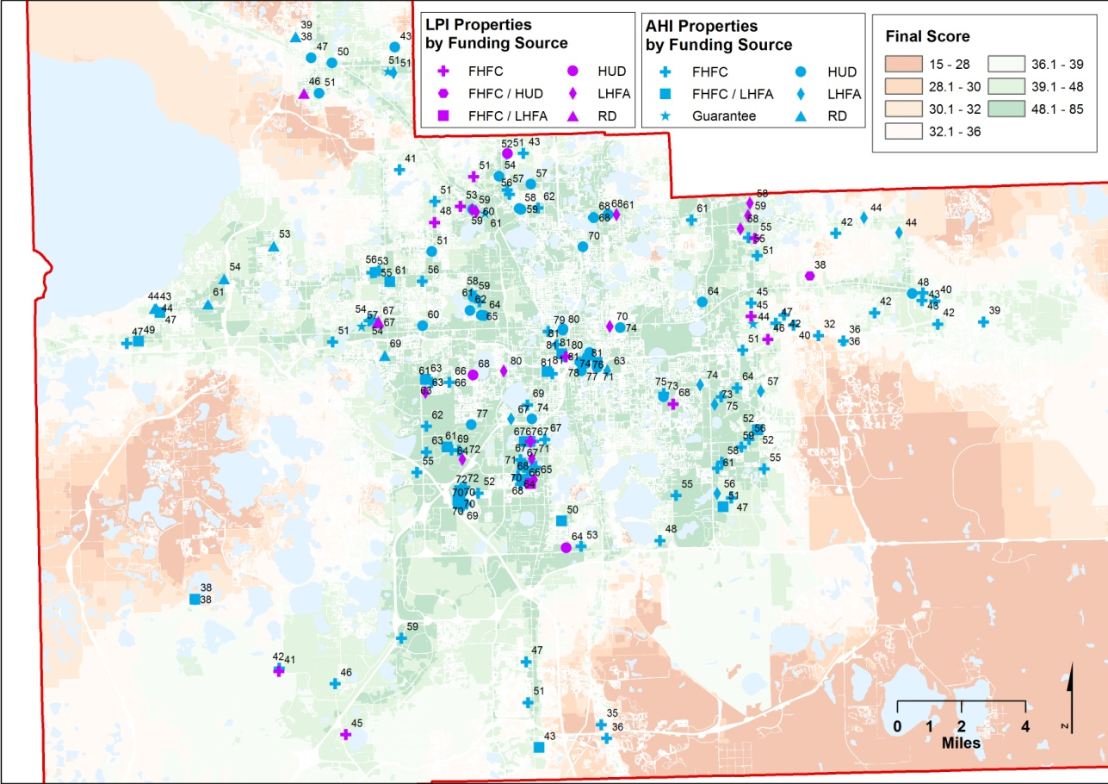

Table 1 presents the average results per component for the AHI, the LPI and the parcels in Orange County. The 202 properties that have received assistance at some point present general scores that fare better not only than the average for parcels in the county but also than the average for multifamily parcels. This means that these properties have more central locations than the average in a county characterized by urban sprawl.
Table 1: Average results for the Assisted Housing Inventory (AHI), the Lost Properties Inventory (LPI), and the entire universe of parcels
 | Frequency | Infrastructure + Environmental Characteristics (I) | Neighborhood Characteristics (N) | Neighborhood Accessibility (NA) | Residential Suitability Score (I+N+NA=R1) | Rental Cost (R2) | Driving Cost (D) | Transit Accessibility (T) | Final Score = R1+R2+D+T
AHI | 168 | 3.80 | 5.39 | 4.97 | 15.04 | 16.33 | 16.29 | 9.73 | 58.85
LPI | 34 | 3.88 | 5.82 | 5.32 | 15.91 | 17.00 | 15.44 | 10.21 | 60.09
TOTAL ASSISTED | 202 | 3.82 | 5.47 | 5.03 | 15.18 | 16.45 | 16.14 | 9.81 | 59.05
MULTIFAMILY PARCELS | 6,987 | 4.20 | 5.20 | 5.00 | 14.40 | 15.90 | 16.30 | 8.50 | 55.10
TOTAL PARCELS | 371,314 | 3 | 6.4 | 2.9 | 12.3 | 12.6 | 13.9 | 2.9 | 41.7
Note: The scores for the multifamily residential parcels and the total parcels are based on a representative sample.

The ‘urban premium’ of suitability explains why the total assisted stock has higher scores in most of the components of the AHS especially those related to accessibility: infrastructure and environment, neighborhood accessibility, residential suitability, driving cost, and transit accessibility. Rental cost is also more suitable for the stock that has received assistance than to the average of the parcels, reflecting more affordability in these locations as it relates to average incomes. However, neighborhood characteristics are worse than the average of parcels in the county reflecting a tendency of the assisted stock to locate in areas with difficult socio-economic conditions. As the maps including in the appendix show this is related to a dynamic that we can term ‘the urban trade-off’: central locations are more accessible and present better infrastructure but at the same time they tend to concentrate poverty, crime and low education attainment.
From the 202 properties that have received assistance, 168 (83.17%) are still in the assisted inventory and 34 (16.83%) were lost. The properties that are no longer assisted have better infrastructure and environmental characteristics, neighborhood characteristics, neighborhood accessibility, residential suitability, rental cost, and transit accessibility. This is reflected in a higher final score for the LPI and is related to its more central location. In effect, as shown in Figure 2, the AHI has a more disperse pattern than the LPI. Driving costs scores, however, are better in the AHI, which is consistent with locations that are closer to the main highways in the county.
Nevertheless, the differences in the means for the AHI and the LPI are not statistically significant, with the exception of the total score for residential suitability. This could be because of the small sample size of the LPI. It can also suggest that a big part of the difference between those properties that remained in the assisted inventory and those that left is explained by characteristics of the property rather than by locations or characteristics of the neighborhood. In fact, different studies have concluded that the probability of staying in the assisted stock depends on some variables that are not included in the AHS. For instance, it increases with the number of units and the percentage of units that are receiving subsidies and it decreases for non-profit owners (Finkel et al, 2006). Nonetheless, these studies have also provided evidence that locations and conditions of the neighborhood are important, especially when considering their dynamic change in the short run.
  - Program analysis
As shown in table 2, properties funded by HUD have the best final score in the AHS. These properties include programs of rental assistance under section 8, capital advance and direct loans under section 202, below the market rates loans under section 236 and 221(d)(3), mortgage insurance under section 542, and capital advance for persons with disabilities under section 811.

Table 2: Average results per program
 | Frequency | Infrastructure + Environmental Characteristics (I) | Neighborhood Characteristics (N) | Neighborhood Accessibility (NA) | Total Residential Suitability Score (I+N+NA=R1) | Rental Cost (R2) | Driving Cost (D) | Transit Accessibility (T) | Final Score = R1+R2+D+T
HUD | 36 | 4.61 | 4.44 | 5.86 | 15.89 | 17.83 | 16.58 | 13.14 | 64.89
LHFA | 28 | 4.18 | 5.25 | 5.61 | 15.89 | 16.86 | 17.21 | 11.89 | 63.54
FHFC+LHFA | 24 | 4.00 | 5.25 | 4.88 | 15.08 | 15.88 | 16.79 | 12.46 | 61.92
FHFC | 93 | 3.53 | 6.11 | 4.68 | 15.11 | 15.63 | 16.02 | 8.02 | 56.19
Guarantee | 8 | 3.50 | 5.88 | 4.75 | 15.00 | 17.38 | 14.38 | 6.88 | 54.88
RD | 12 | 2.83 | 4.08 | 4.50 | 12.50 | 18.42 | 13.75 | 6.08 | 52.08
FHFC+HUD | 1 | 2.00 | 7.00 | 4.00 | 13.00 | 13.00 | 9.00 | 2.00 | 38.00
TOTAL ASSISTED | 202 | 3.82 | 5.47 | 5.03 | 15.18 | 16.45 | 16.14 | 9.81 | 59.05
% Significance |  | 14.29% | 19.05% | 33.33% | 23.81% | 23.81% | 33.33% | 38.10% | 47.62%
Note: % Significance means the proportion of differences among programs that were significant at 5%

HUD properties tend to fare better in the components related to accessibility, getting the highest scores in infrastructure, neighborhood accessibility and transit and some of the highest in total residential suitability and driving costs (see table 3). This is because they have more central locations compared to the other programs. HUD properties also have the second highest rental score showing that this program is affordable in relation to the incomes that prevail in the area. This is not surprising since, in general, these properties include the most stringent income and rent restrictions. However, HUD properties have one of the lowest scores in neighborhood characteristics. This is related to the ‘urban trade-off’ between accessibility and socio-economic conditions noted before.

Table 3: Ranking of results per program
 | Program (high score – low score)
Infrastructure and Environmental Characteristics (I) | HUD LHFA FHFC+LHFA FHFC Guarantee RD FHFC+HUD
Neighborhood Characteristics (N) | FHFC+HUD FHFC Guarantee FHFC+LHFA LHFA HUD RD
Neighborhood Accessibility (NA) | HUD LHFA FHFC+LHFA Guarantee FHFC RD FHFC+HUD
Total Residential Suitability Score (I+N+NA=R1) | LHFA HUD FHFC FHFC+LHFA Guarantee FHFC+HUD RD
Rental Score (R2) | RD HUD Guarantee LHFA FHFC+LHFA FHFC FHFC+HUD
Driving Cost (D) | LHFA FHFC+LHFA HUD FHFC Guarantee RD FHFC+HUD
Transit Accessibility (T) | HUD FHFC+LHFA LHFA FHFC Guarantee RD FHFC+HUD
Final Score = R1+R2+D+T | HUD LHFA FHFC+LHFA FHFC Guarantee RD FHFC+HUD

The ‘urban trade-off’ is also evident in the other extreme of the scores where we can find properties funded by the Florida Housing Financing Corporation (FHFC). These properties are funded mainly by Low-Income Housing Tax Credits (LIHTC) and other programs based on preferential loans and state bonds. This group presents one of the best scores in neighborhood characteristics but medium scores for both accessibility and infrastructure and environmental conditions. This is consistent with their spatial pattern, which is more dispersed, and their location, which is more oriented to second ring suburbs (see Figure 2). The rental score shows low suitability which is consistent with the less stringent restrictions of these programs. Interestingly, the group funded jointly by FHFC and HUD appear to magnify the pattern of the FHFC-only properties. Instead of being influenced by HUD’s good accessibility and bad socio-economic conditions: HUD+FHFC have the worst scores in the first dimension but the best score in the second. However, this group is composed by only one property so the case cannot be considered as representative of a general trend.
Properties funded by the Department of Agriculture and Rural Development (RD) have what appears to be the worst of both worlds: very low accessibility and very bad socio-economic conditions. However, the results in terms of the rental score show high affordability compared to the incomes in the area. These results are expectable since this program is centered in providing rental assistance and soft loans with stringent requirements for the development of housing in very low-income rural areas. Properties funded by Local Housing Finance Authorities (LHFA) through local bonds have the second best final score thanks to a more balanced result in the ‘urban trade-off’ being concentrated in suburban locations to the east with good accessibility provided by access to main highways and also good availability of social services at the neighborhood level. Properties funded jointly by FHFC and LHFA and properties funded by guarantees (an FHFC administered credit enhancement program that works in concert with federal, state and local government financing sources) have medium results in all the categories and the final score.
Figure 3 shows the ‘urban trade-off’ between accessibility and socio-economic conditions through the comparison of the z-scores per program for the components of neighborhood characteristics and neighborhood accessibility. HUD properties present high accessibility and bad socio-economic characteristics which is consistent with their location in low-income areas in the city center. In the case of FHFC properties the conditions reverse given their more suburban spatial pattern. For RD properties both characteristics fare poor since these properties are both rural and oriented to very low-income households with stringent income restrictions. None of the programs have both good socio-economic conditions and high accessibility although properties administered by local authorities (LHFA) come close to.
Figure 3: Comparison of Z-Scores per program for neighborhood characteristics and neighborhood accessibility

  - Analysis by decade of initial funding
Table 4 shows that properties that started to receive funding in the 1960s have the highest final score. From that point on, final scores decrease for subsequent decades reflecting lower suitability conditions. However, this trend changes in the 2000s when properties start to reflect better general suitability scores than those from the 1990s.
Table 4: Average results per decade of initial funding
 | Frequency | Infrastructure + Environmental Characteristics (I) | Neighborhood Characteristics (N) | Neighborhood Accessibility (NA) | Total Residential Suitability Score (I+N+NA=R1) | Rental Cost (R2) | Driving Cost (D) | Transit Accessibility (T) | Final Score = R1+R2+D+T
1960s | 7 | 7.00 | 1.86 | 6.86 | 16.43 | 15.71 | 21.00 | 21.29 | 76.29
1970s | 23 | 4.39 | 4.61 | 5.78 | 15.61 | 18.30 | 15.78 | 13.83 | 65.13
1980s | 43 | 3.65 | 5.51 | 5.28 | 15.35 | 16.93 | 16.37 | 9.47 | 59.70
1990s | 78 | 3.58 | 5.73 | 4.71 | 14.85 | 16.19 | 15.64 | 7.65 | 55.65
2000s | 51 | 3.63 | 5.90 | 4.73 | 15.20 | 15.69 | 16.22 | 10.00 | 58.61
% Significance |  | 50.00% | 50.00% | 80.00% | 0.00% | 40.00% | 40.00% | 80.00% | 50.00%
Note: % Significance means the proportion of differences among programs that were significant at 5%

Higher final scores in the 1960s properties are explained by their central locations (figure 4) and reflected in higher accessibility conditions. As table 5 shows, every component related to access fares very well for these properties: infrastructure and environmental characteristics, neighborhood accessibility, driving cost, and transit accessibility. However, once again, the neighborhood characteristics score of this group is very low reflecting poor socio-economic conditions. In general the ‘urban trade-off’ is consistent for every decade with properties becoming less accessible but better in terms of socio-economic indicators. Essentially, as time passes by properties get more suburbanized and the city center declines. The consistency of this pattern is exemplified by the high percentage of significant differences among the means of each component per decade.

Figure 4: Final scores for the Assisted Housing Inventory (AHI), the Lost Properties Inventory (LPI), and the entire universe of parcels according to decade of initial funding
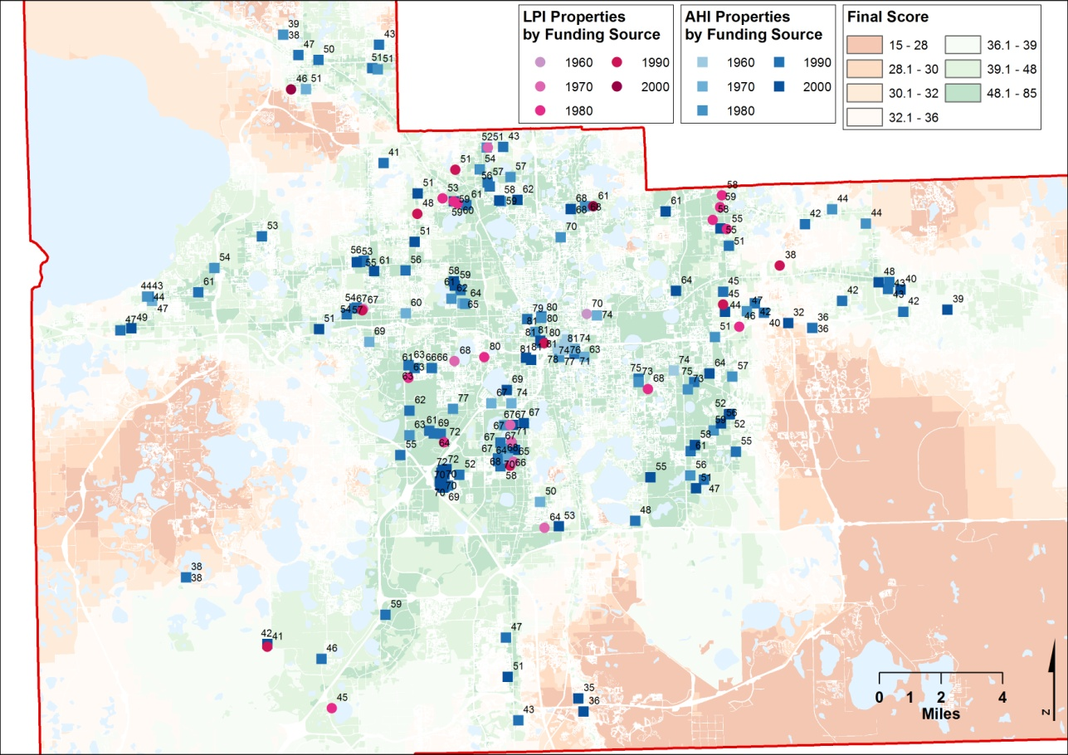

Table 5: Ranking of results per decade of initial funding
 | Decade (high score – low score)
Infrastructure and Environmental Characteristics (I) | 1960 1970 1980 2000 1990
Neighborhood Characteristics (N) | 2000 1990 1980 1970 1960
Neighborhood Accessibility (NA) | 1960 1970 1980 2000 1990
Total Residential Suitability Score (I+N+NA=R1) | 1960 1970 1980 2000 1990
Rental Score (R2) | 1970 1980 1990 1960 2000
Driving Cost (D) | 1960 1980 2000 1970 1990
Transit Accessibility (T) | 1960 1970 2000 1980 1990
Final Score = R1+R2+D+T | 1960 1970 1980 2000 1990

As noted, the 2000s represent a change in the trend with properties getting higher scores in all the components related to accessibility while still maintaining the improvements in socio-economic characteristics. In effect, the 2000 scores are better than the 1990s ones for every component except for the rental score. In some cases, notably transit accessibility, the score in the 2000s is even better than in the 1980s. These patterns, which are enough to change the declining trend in the final scores, are associated with changes in public policy priorities as funders, particularly FHFC, have started to add points for accessibility (especially transit) in their process of evaluation. In this regard, it is important to note that the different trends by program described in the previous section are also associated with changes in the relative composition of the assisted stock according to decade since in the 1960s and 1970s HUD properties were prevalent whereas FHFC properties are the majority in the 1990s and the 2000s.
Table 6: Properties per program according to decade of initial funding
 | 1960s | 1970s | 1980s | 1990s | 2000s | TOTAL
HUD | 4 | 10 | 11 | 5 | 6 | 36
LHFA | 3 | 8 | 15 |  | 2 | 23
FHFC+LHFA |  | 3 | 2 | 6 | 13 | 29
FHFC |  |  | 11 | 55 | 27 | 93
Guarantee |  |  |  | 6 | 2 | 8
RD |  | 2 | 4 | 5 | 1 | 12
FHFC+HUD |  |  |  | 1 |  | 1
TOTAL ASSISTED | 7 | 23 | 43 | 78 | 51 | 202

- CONCLUSIONS
The AHS model allows the evaluation of the assisted inventory in terms of different conditions that are relevant for the development and preservation of affordable housing. Studying the case of Orange County in Florida, we can conclude that, in general, properties that have received assistance at some point since the 1960s have better access to infrastructure, to neighborhood social services, and to regional destinations, both by driving and transit, than the average of parcels in the county. The ratio of rental costs to income is also lower reflecting more affordability in these locations. However, socio-economic conditions are worse in the areas where the assisted stock tends to be located than the average of parcels in the county.
This dynamic represent an ‘urban trade-off’ between accessibility and socio-economic indicators that is consistent in the other sets of comparisons conducted with the AHS. For instance, properties that joined the assisted inventory in the 1960s and the 1970s and that are primarily funded by HUD present excellent accessibility conditions but poor socio-economic characteristics. For properties funded for the first time in the 1990s and the 2000s, in which funding by the FHFC is prevalent, the situation is reversed. This is related to the process of urban growth in which suburbanization and sprawl are coupled with decline in the city center and the inner suburban rings. However, the pattern is not entirely unavoidable since the 2000s represent a change in which properties start to present both better accessibility and socio-economic conditions than those of the 1990s. This reflects new directions of public policy that conceptualize transportation costs as part of housing affordability.
Another conclusion from this study is that properties that have left the assisted inventory have better suitability conditions than those properties that stayed. This is important for public policy because it represents an additional challenge for policy makers since the success in improving the accessibility and socio-economic conditions of the assisted stock can represent the conditions for its failure in the long term as more properties become at risk to opt-out from contracts and income and rent requirements. In that regard, it is important to be sure that a preservation dimension is added to the necessary efforts to improve the stock.
This paper presented some of the potential uses of suitability tools for housing policy through the use of the AHS model to evaluate the assisted stock. Modeling is a continuous effort and as such there are still things to modify in the AHS especially as they relate to adjusting the weighting mechanisms to the actual demands and policy needs for each locality. However, the partial results show that this type of tools can be of great help not only to add a spatial dimension to the process of decision making but also to visualize the results and assist in providing more, and more accessible, information to the community.
- REFERENCES

Al-Shalabi, M. A., Mansor, S. B., Ahmed, N. B., & Shiriff, R. (2006, October). GIS Based Multicriteria Approaches to Site Suitability Analysis. Paper presented at the XXII FIG Congress, Munich, Germany.
Biermann, S. M. (1999). The strategic identification of land suitable for low income housing: A case study from South Africa. In J.-C. Thill (Ed.), Spatial multicriteria decision making and analysis: A geographic information sciences approach (pp. 199–221). Aldershot: Ashgate.
CNT (2010). Penny wise, pound fuelish: New measures of housing and transportation affordability. Retrieved May 12, 2010, from http://www.cnt.org/publications
CSIR (2005). Housing Atlas 2005: National Spatial Investment Potential for Housing: Council for Scientific and Industrial Research in South Africa (CSIR). Retrieved 7/31/08, from www.housing.gov.za/content/Housing%20Atlas%2005/document.htm.
Finkel, M., Hanson, C., Hilton, R., Lam, K., & Vandawalker, M. (2006) “Multifamily properties: Opting in, opting out and remaining affordable”. Prepared for the U.S. Department of Housing and Urban Development, Office of Policy Development and Research. Contract No. GS-10F-0269K. Available at http://www.huduser.org/intercept.asp?loc=/Publications/pdf/opting_in.pdf
Khadduri, J. & Wilkins C. (2008) “Designing Subsidized Rental Housing Programs” in Revisiting Rental Housing: Policies, Programs and Priorities. Ed. Nicolas P. Retsinas and Eric S. Belsky. Brookings Institution, Washington DC. Pages 161-90.
Hamir, A., Mallozzi, N., & Traynor, K. (2003). Building a Better Future: Housing Development Opportunities in Worchester. Worcester, MA: Worcester Polytechnic Institute.
Hartman, C. (1998). The case for a right to housing. Housing Policy Debate, 9(2), 223–246.
Hester, K., & Radford, M. (2005). Using a Gis-Based Model to Identify Suitable Mixed-Income Housing Development Sites within the City of Chicago. Retrieved 1/19/2007, from http://www.uoguelph.ca/geography/research/geog4480_w2005/Group01/.
Higgs, G. (2006). Integrating multicriteria techniques with geographical information systems in waste facility location to enhance public participation. Waste Management & Research, 24, 105–117.
McHarg, I. L. (1969). Design with nature. New York: John Wiley and Sons, Inc.
Miller, W., Collins, M. G., Steiner, F., & Cook, E. (1998). An approach to greenway suitability analysis. Landscape and urban planning, 42, 91–105.
Newman S, & Schnare A (1997) “And a suitable environment: the failure of housing programs to deliver on neighborhood quality” Housing Policy Debate 8(4) 703 – 741
Pereira, J. M. C., & Duckstein, L. (1993). A multiple criteria decision-making approach to GIS-based land suitability evaluation. International Journal of Geographic Information Science, 7(5), 407–424.
Ray, Anne et al (2009) “The State of Florida’s Assisted Rental Housing”. Available at http://flhousingdata.shimberg.ufl.edu
Shimberg Center for Housing Studies (2010) Lost Properties Inventory Data. Available at http://flhousingdata.shimberg.ufl.edu/a/lpi
Shimberg Center for Affordable Housing (2008). A risk assessment method for preservation of assisted rental housing. Available at http://flhousingdata.shimberg.ufl.edu/AHI_introduction.html
Sorrentino, J. A., Meenar, M. R., & Flamm, B. J. (2008). Suitable housing placement: A GIS-based approach. Environmental Management, 42, 803–820.
Stienitz, C., Parker, P., & Jordan, L. Hand-drawn overlays: Their history and prospective uses. Landscape Architecture, 9, 444–455.
Steiner, F. (1983). Resource suitability: Methods for analysis. Environmental Management, 7(5), 401–420.
Store, R., & Kangas, J. (2001). Integrating spatial multi-criteria evaluation and expert knowledge for GIS-based habitat suitability modeling. Landscape and Urban Planning, 55, 79–93.
Svatos, V. C., & Doucette, J. S. (2003). Analyzing Suitability of Land for Affordable Housing. Paper presented at the ESRI International User Conference, July 7-11, 2003, San Diego, CA. Retrieved June 4, 2010, from http://proceedings.esri.com/library/userconf/proc03/p0339.pdf
Thomson, C. N., & Hardin, P. (2000). Remote sensing/GIS integration to identify potential low-income housing sites. Cities, 17(2), 97–109.
Trust for Public Land. (2005). Greenprint for King County. Retrieved June 4, 2010, from http://www.tpl.org/tier3_cd.cfm?content_item_id=18178&folder_id=262

APPENDIX

Table A1: AHI and LPI properties per program according to decade of initial funding
 | 1960s |  | 1970s |  | 1980s |  | 1990s |  | 2000s |  | TOTAL
 | AHI | LPI | AHI | LPI | AHI | LPI | AHI | LPI | AHI | LPI | AHI | LPI
HUD | 4 |  | 7 | 3 | 11 |  | 5 |  | 6 |  | 33 | 3
LHFA | 2 | 1 | 3 | 5 | 7 | 8 |  |  | 1 | 1 | 13 | 15
FHFC+LHFA |  |  | 3 |  | 2 |  | 5 | 1 | 13 |  | 23 | 1
FHFC |  |  |  |  | 6 | 5 | 49 | 6 | 27 |  | 82 | 11
Guarantee |  |  |  |  |  |  | 6 |  | 2 |  | 8
RD |  |  | 1 | 1 | 4 |  | 4 | 1 |  | 1 | 9 | 3
FHFC+HUD |  |  |  |  |  |  |  | 1 |  |  |  | 1
TOTAL ASSISTED | 6 | 1 | 14 | 9 | 30 | 13 | 69 | 9 | 49 | 2 | 168 | 38

Figures A1: Maps of suitability per component of the AHS
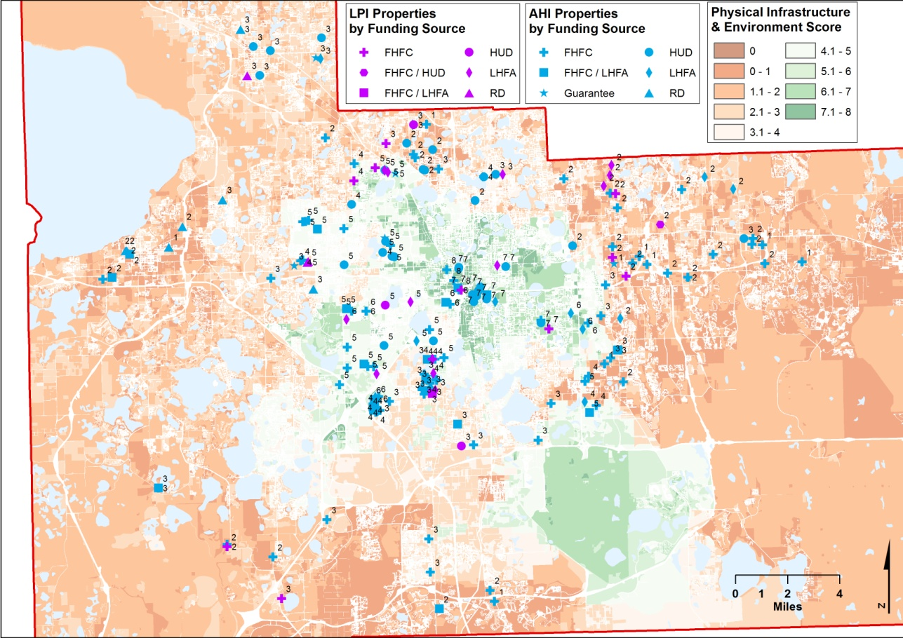

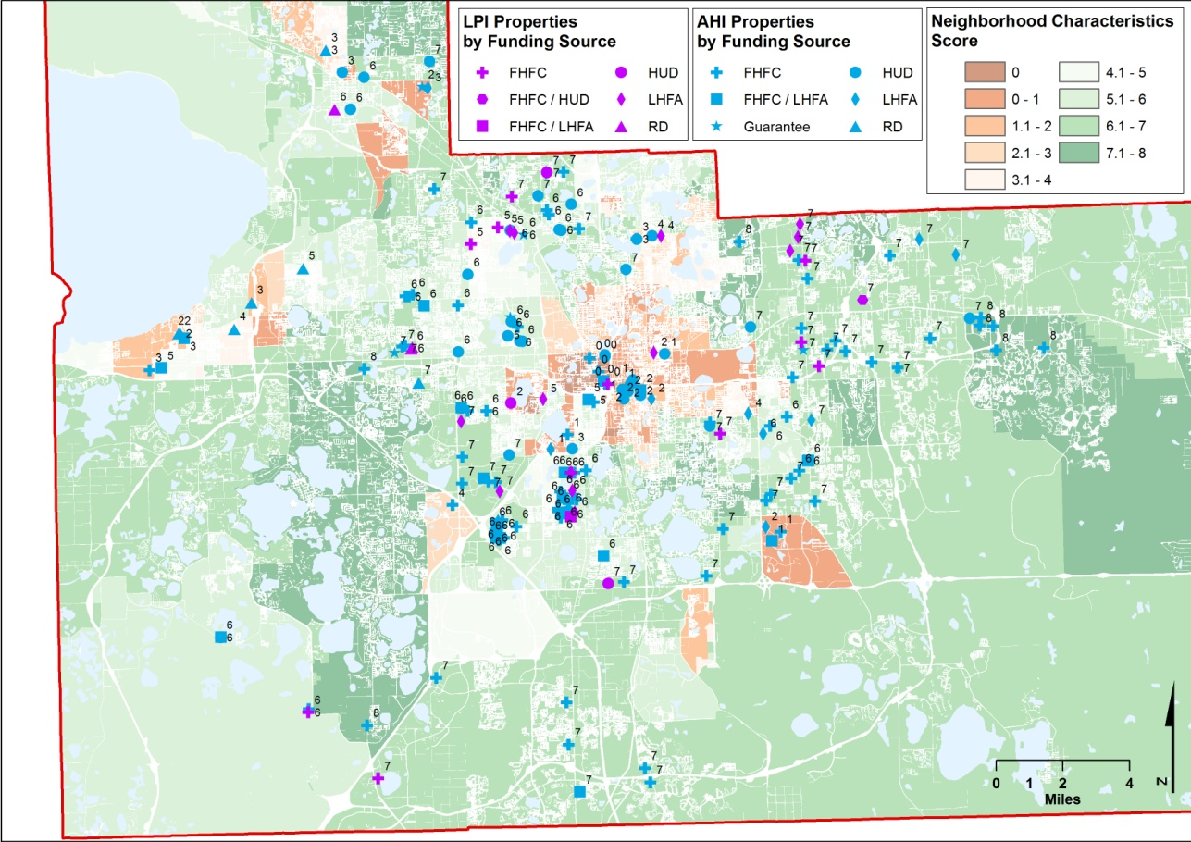

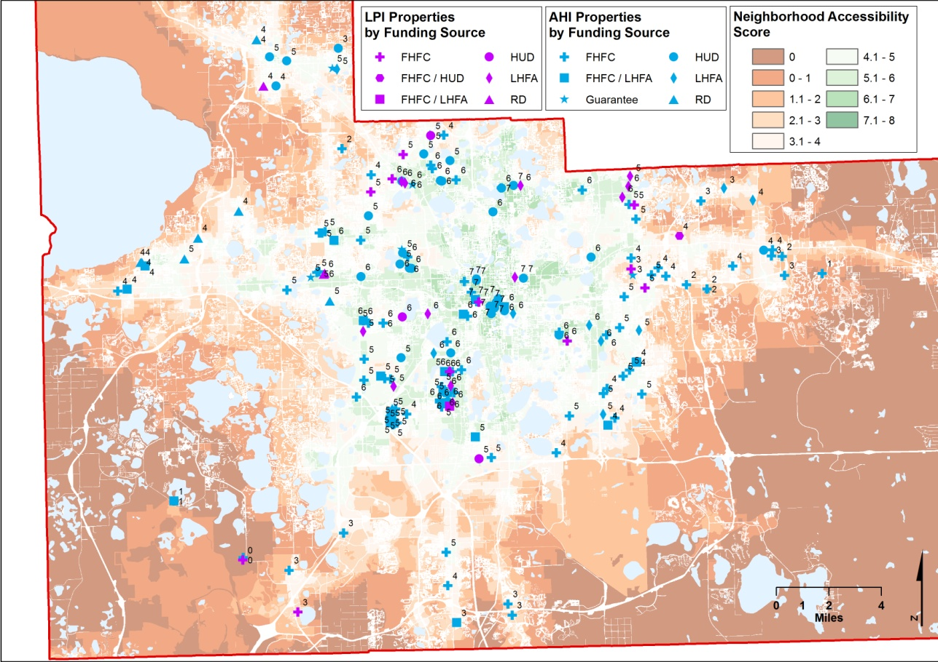
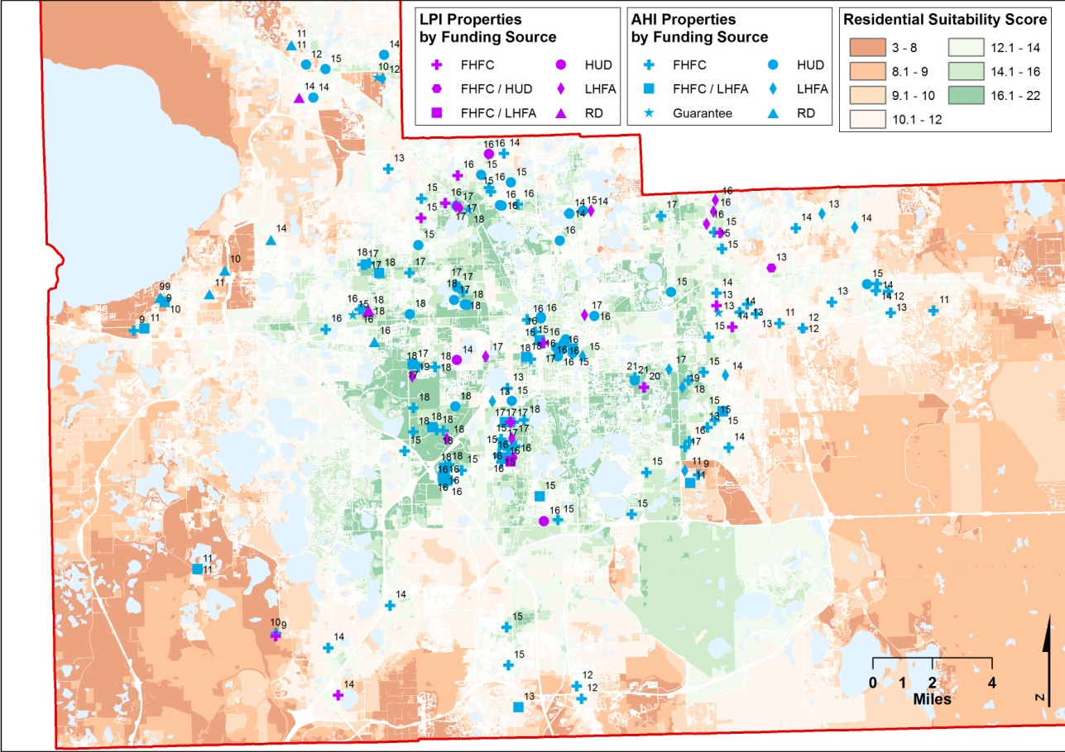

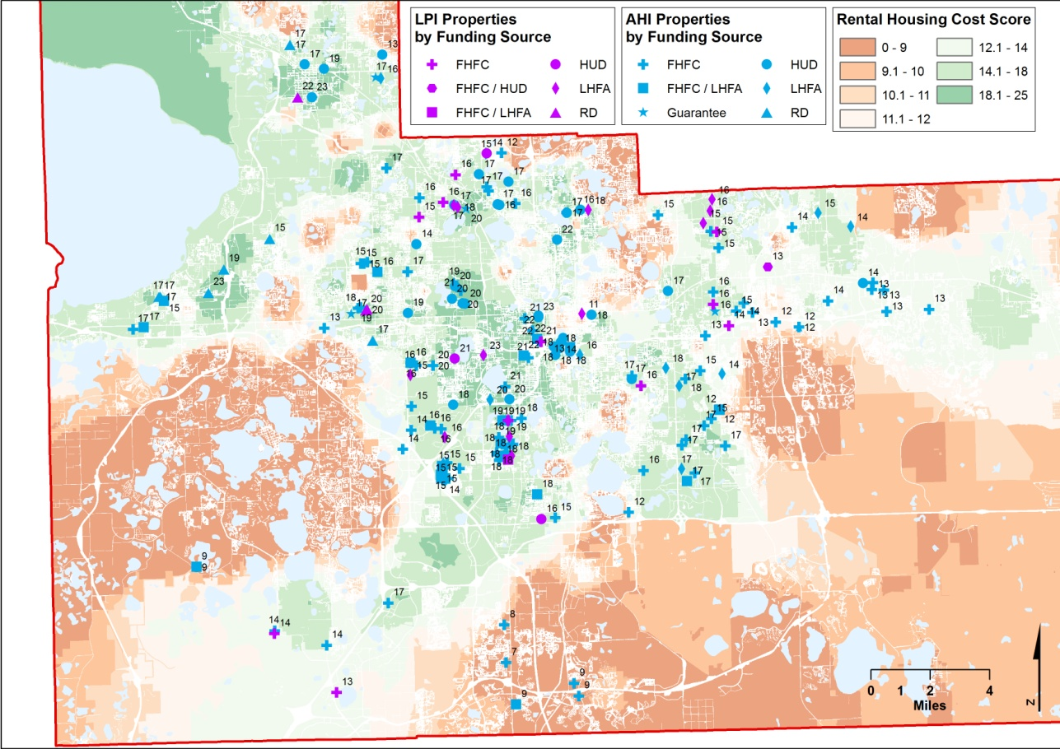
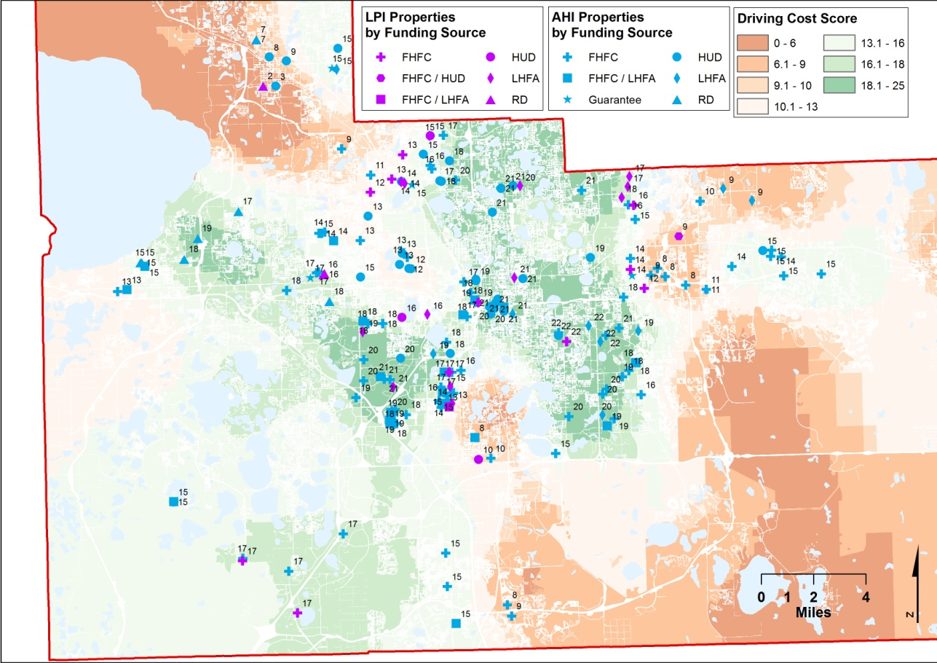

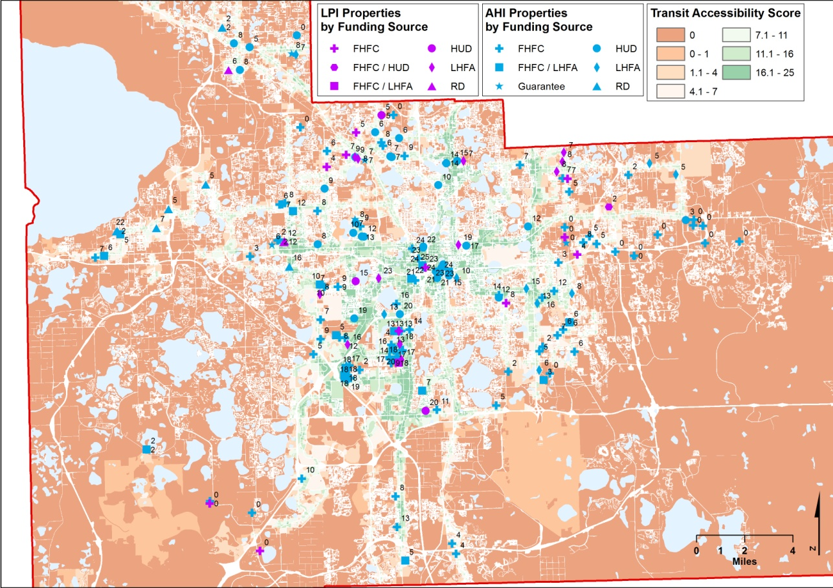
Figures A2: Correlation of final scores and other variables
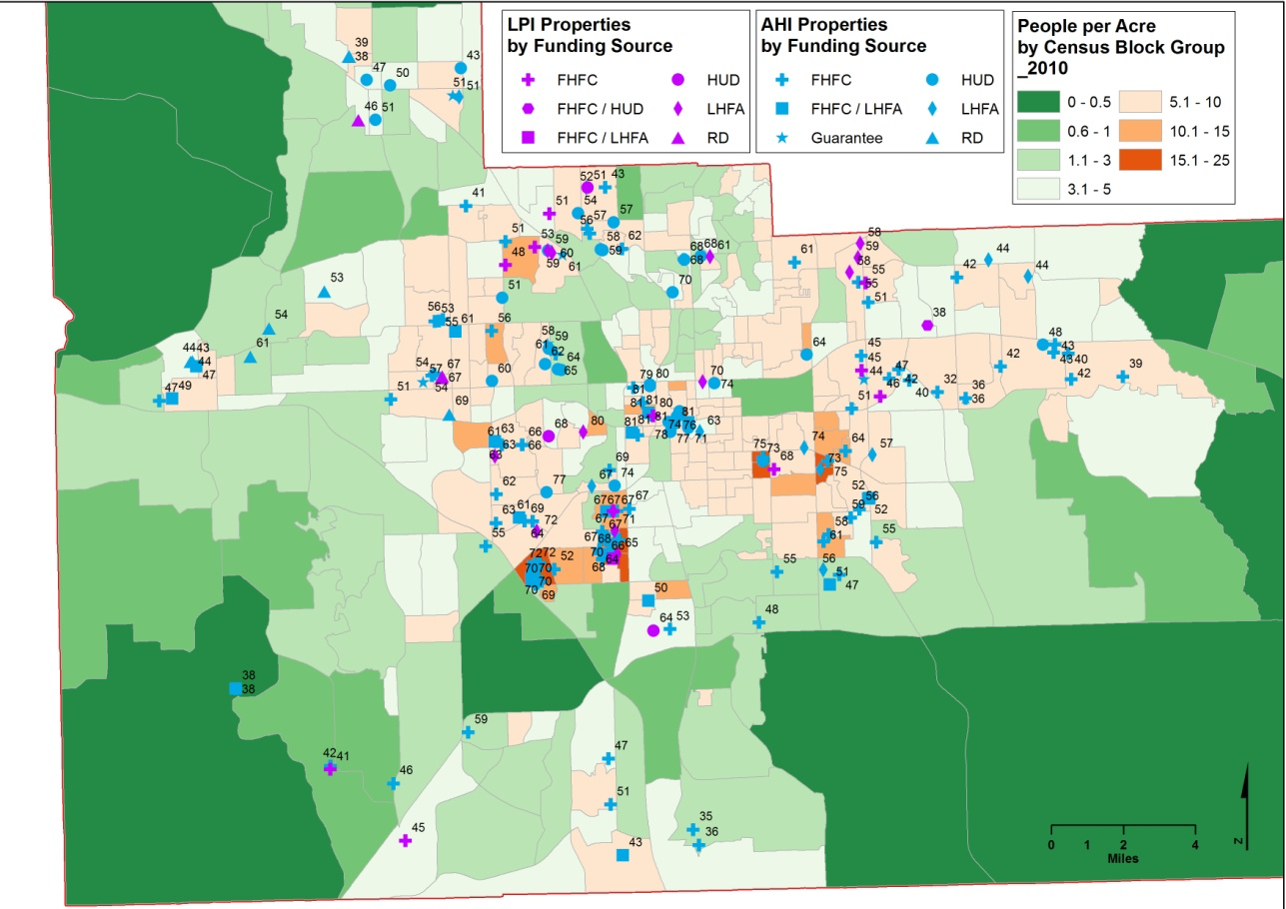
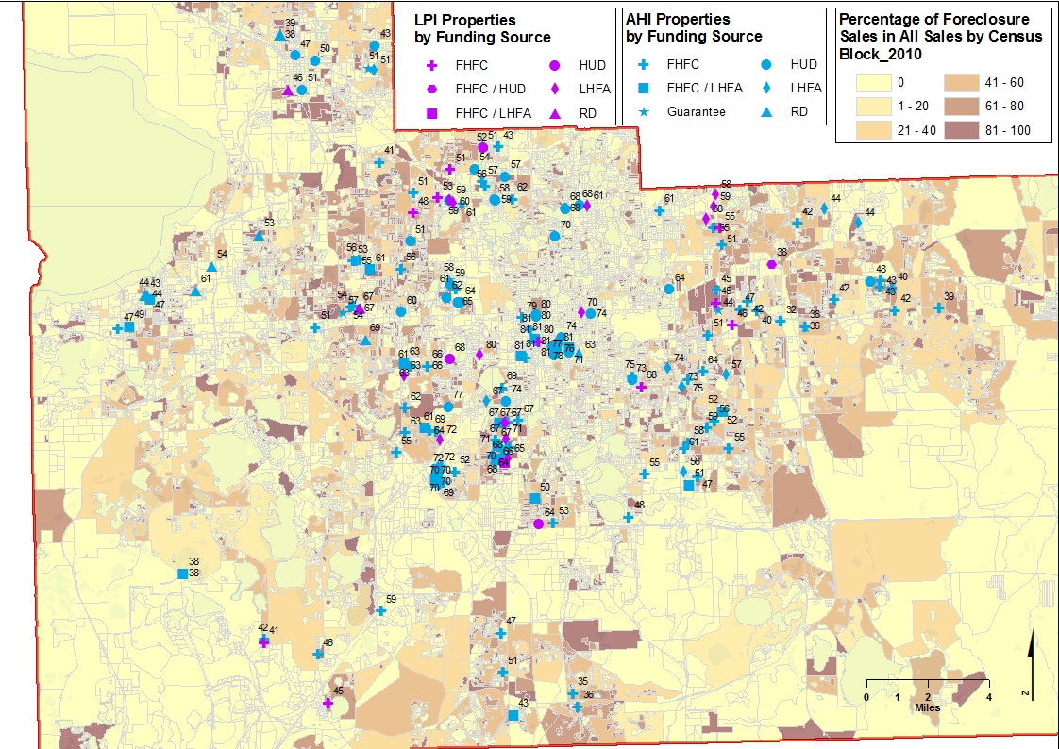
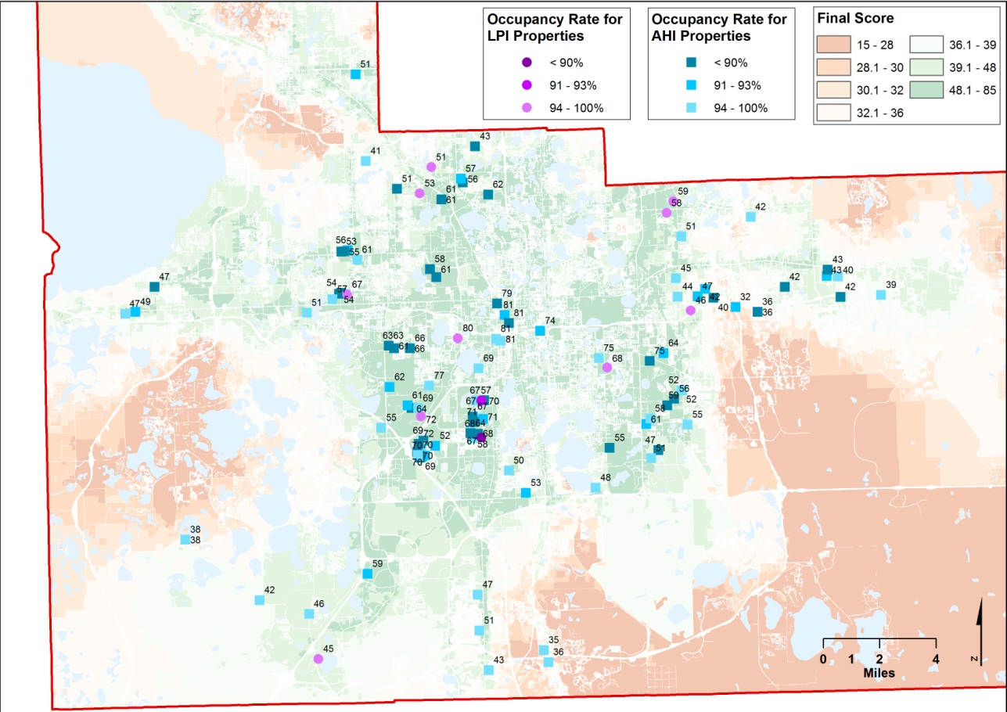

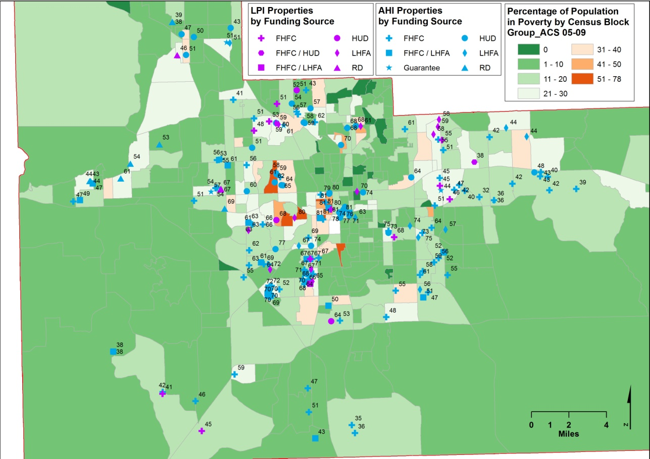

See http://www.fgdl.org

