Helping Put Theory into Practice for Planning Sustainable Communities: A GIS Tool for Measuring Transit Accessibility
Elizabeth Thompson (University of Florida), Abdulnaser Arafat (University of Florida), William O’Dell (University of Florida), Ruth Steiner (University of Florida), Paul Zwick (University of Florida)

Presenter’s Email Address: liz.thompson@ufl.edu

Abstract
Understanding transit accessibility as it relates to housing and employment for low income households is important for policymakers attempting to implement sustainable community initiatives. This paper introduces a new tool for evaluating transit accessibility that differs from commonly-used straight-line proximity measurements between places and activities. Using geographic information systems (GIS) this tool creates a disaggregate parcel-level accessibility measurement that highlights how well individual locations are served by a transit system.
In this paper multifamily rental properties receiving government subsidies in five Central Florida counties are assessed for their accessibility to major employment centers using public transit. The analysis shows that while the majority of properties had good access to transit stops by walking, 75% of them had poor accessibility to major employment locations using the transit system. The policy implication underscored by this paper is that more precise measures of accessibility should be incorporated into decisions concerning the location of affordable housing and employment opportunities if we hope to plan sustainable communities.
Introduction
The increased interest in recent years in the United States in transit-oriented development is an example of urban planning efforts to put sustainability initiatives into practice. Bringing people and jobs closer together, through more efficiently configured land use and transportation systems advances environmental goals as well as increasing social and economic opportunities within and between communities by making more places accessible to more people (Been et al., 2010). As this process unfolds in many cities, the crucial role that accessibility plays in the design of public transit systems is becoming increasingly clear. Not only is the planning and design of transit station precincts important but so too are their regional locations and their ability to efficiently connect one destination to another, particularly housing to jobs (Curtis & Scheurer, 2010).
Policymakers looking to include transit accessibility measurements into sustainability initiatives face several challenges. Accessibility is a complex concept and there are many methods for measuring it (Lei and Church, 2010) leaving much room for debate about which method is most appropriate or accurate. Another, and one this paper aims in part to remedy, is the lack of practical tools available for measuring transit accessibility, particularly at small enough scales to facilitate site-specific evaluations, like those necessary for determining prime locations for affordable housing.
The question of where best to site transit stops and stations to maximize housing and employment opportunities centers largely on evaluating how accessible locations are to the people who use them and the places they need to go (Tomer, Kneebone, Puentes & Berube, 2011). For low-income households in particular, access to public transportation that efficiently connects residential and employment locations offers a safety-net for those without personal vehicles as well as a cost saving to those who may own vehicles but cannot afford to use them to travel to work.
Some states like Florida emphasize proximity to public transit in their assessment of applications for funding of assisted housing developments as a way to promote sustainability. Assisted housing, in this paper, refers to privately-owned rental housing that receives public subsidies in exchange for accepting restrictions on tenant income (Shimberg Center, 2009). In Florida developers receive tie-breaker points of varying amounts for developments based on their proximity to different types of transit, such as bus or bus rapid transit stops and rail stations (Florida Housing Finance Corporation, 2011). Proximity to stops, however, is only part of the equation necessary for measuring transit accessibility. The number of destinations that can be reached and the service frequency provided at each stop are just as important measurements. This is supported in the literature on accessibility which highlights that it is the ease or convenience of reaching opportunities for activity or service that characterizes accessibility, not simply whether locations are proximal to others (Handy, 2002; Hanson, 2004; Primerano and Taylor, 2005; Lei and Church, 2010). In terms of transit accessibility, this can mean the combination of several measurements such as the ability to walk to transit stops, the convenience of using the transit system, and the accessibility of destinations to transit stops (Mavoa et.al., 2012).
This paper introduces a new tool for evaluating transit accessibility that differs from commonly-used aggregate measures that apply simple straight-line proximity measurements between places and activities. Based on research that uses a network stop-route accessibility methodology (Lee, 2004) this tool uses geographic information systems (GIS) to create a disaggregate parcel-level accessibility measurement. The tool is capable of generating a map that depicts accessibility to employment locations using public transit for all locations in a study area. Rather than using Euclidean measurements, the tool uses walk-able network distances that more realistically capture traveler behavior and land use and transit system characteristics.
To demonstrate the tool’s capabilities this paper evaluates multifamily rental properties receiving government subsidies in five Central Florida counties using the tool to assess their accessibility to employment locations via the LYNX bus transit system. The results highlight individual affordable housing developments with poor transit accessibility to major employment locations in the region and that many would benefit from improved transit service. The study demonstrates the importance of understanding small-scale, property-level accessibility in planning and preserving locations for affordable housing, and highlights the contribution the transit accessibility tool can make to planners attempting to put sustainable development principles into practice.
Transit Accessibility Tool
Development of a transit accessibility tool was undertaken by the Shimberg Center for Housing Studies at the University of Florida as part of its ongoing development of the Affordable Housing Suitability model (AHS), a decision-support tool to assist in the identification and preservation of suitable locations for affordable housing development.
The transit accessibility tool uses GIS software to calculate several measurements that are combined to provide a total accessibility score for all locations within a study area. Firstly it measures the accessibility of locations to the transit system by walking. The accessibility of transit stops is then calculated in terms of their utility in reaching destinations of opportunity. In other words, it measures how convenient each transit stop is in reaching locations of interest, such as retail, service or employment locations. When combined, the measurements provide an index representing how well the transit system provides access to opportunities from all locations within a study area.
The specific focus of this study is on the accessibility of assisted housing developments to major employment locations provided by the LYNX bus transit system in Central Florida which serves Orange, Osceola, Seminole and Volusia counties, as well as small portions of Lake and Polk counties (Figure 1). A transit system service area is used as a “catchment zone” for determining employment locations and locations accessible to the transit system. It is based on a four-mile network distance of the system routes which represents a reasonable biking distance to transit as well as incorporating shorter more walk-able distances.
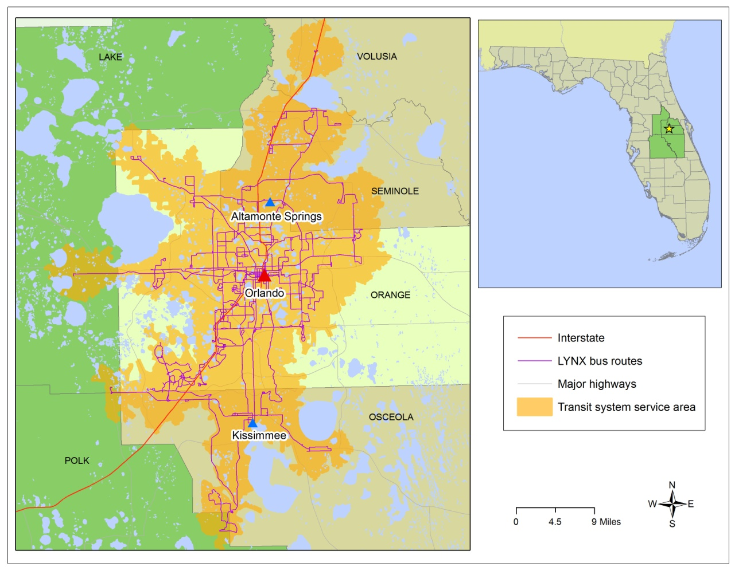
Figure 1 – The LYNX Bus Transit System and Service Area
An accessibility score is calculated for all locations within the transit system service area, which is comprised of two components that are scored as follows:
- A walk score – representing the network distance to the nearest transit stop from all locations within an 800-meter walking network buffer of the transit routes (maximum score 25); and
- An employment access score – representing the opportunity that exists at each transit stop in reaching major employment destinations that are within walking distance (800 meters) of transit stops (maximum score 25).
The two components are combined to create a total accessibility score, the maximum possible score being 50.
Walk scores are created for all locations in the study area through a process using spatial interpolation within the GIS. The process begins by creating 5,000 randomly selected points within the transit service area and calculating distance values for those locations. Values for surrounding locations are then estimated based upon the known values using an inverse-distance weighting technique. The final step in creating the walk scores involves converting the distance measurements to a 0 to 25 score using a linear transformation equation.
The employment access score is calculated through the use of an origin-destination matrix which is created within the GIS using network analysis tools. The GIS calculates the least-cost trip, or shortest and most frequent trip, from all origins to all destinations in the transit service area using the transit routes (Figure 2). In this study, origins are all the stops along the transit system and destinations are those stops that are within an 800-meter network walking distance to a major employment location. Major employment locations with 100 or more employees were determined using proprietary data acquired for the study. The rationale for using a 100-employee threshold was reached following a careful spatial assessment of the data that showed a large proportion of smaller employment locations are clustered around many major employment locations, indicating that scores for these centers could effectively be interpolated to surrounding locations.

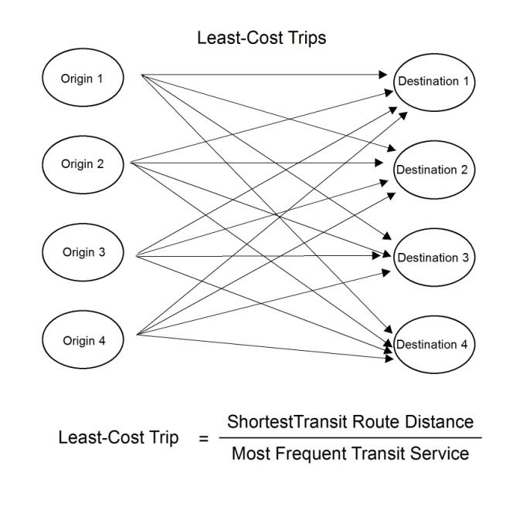
Figure 2. Least-Cost Trips from All Origins to All Destinations

An employment access score for each transit stop, or origin, is calculated by averaging the least-cost trips to all destinations that can be reached from each transit stop (Figure 3). Similar to the walk scores, the employment access measurements are then converted to a 0 to 25 score using a linear transformation equation. The score for each transit stop is representative of the average utility each stop provides in using the transit system to travel to major employment locations in the service area.

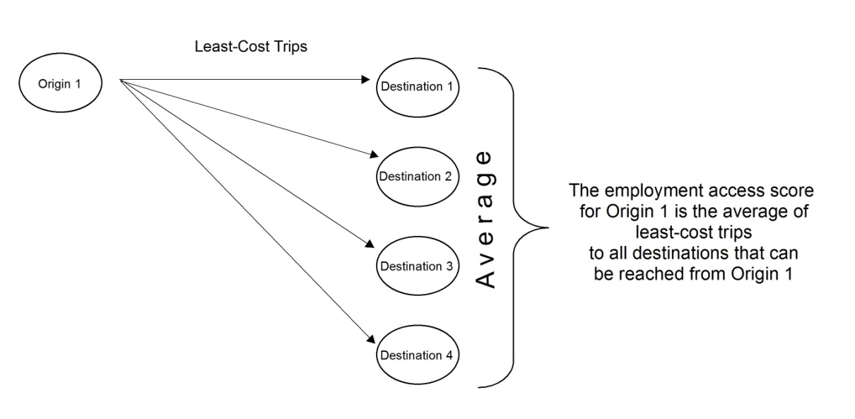
Figure 3. Employment Access Score

The scores for each of the two components (walk and employment access scores) are stored in individual spatial datasets which can be overlain in the GIS so that for any specific point within the transit service area a value for each of the components can be retrieved. The individual spatial datasets can be combined into one within the GIS so a composite score is known for each location. This provides a useful measurement for comparing locations across the service area as well as understanding which factors are contributing to the level of accessibility in individual locations.

Assisted Housing Developments and Transit Accessibility in Central Florida
The transit accessibility tool was used to calculate accessibility scores for assisted housing developments that are located within the LYNX transit system service area. Assisted housing developments are privately owned multi-family rental housing that receive subsidies from federal, state and local governments (Shimberg Center, 2012). According to data collected by the Shimberg Center for Housing Studies, in 2011 there were 256 assisted housing developments located within the service area which housed 32,602 households, 92% of which were family households. By U.S. Department of Housing and Urban Development (HUD) standards, 14% of developments had average incomes for assisted households that could be categorized as being extremely low-income (0 to 30% of the area median income), and 59% of developments as having assisted households that were very low income (30.1 to 50% of the area median income).
The total accessibility scores for the transit service area are shown in Figure 4. To facilitate an analysis of scores for the assisted housing developments, a summary of the scores for all locations within the service area is shown in Table 1. These descriptive statistics are used as thresholds for categorizing the assisted housing developments according to how accessible the developments are compared to all other locations within the service area.
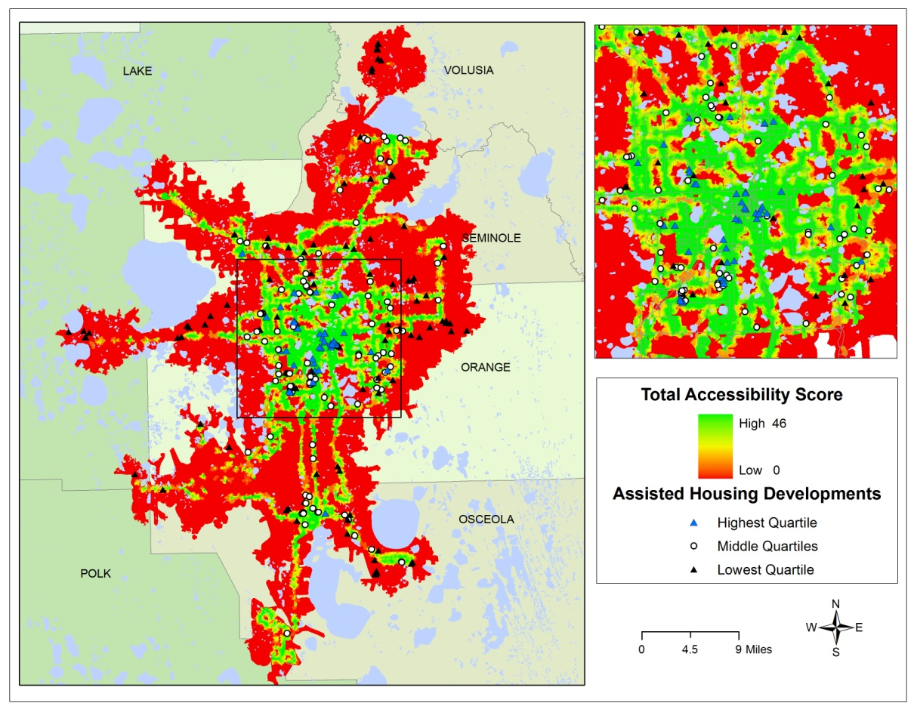
Figure 4. Total Accessibility Scores and Assisted Housing Developments

Table 1. Descriptive Statistics for All Locations in Transit System Service Area
 | Total Score | Walk Score | Employment Access Score
Minimum Score | 0 | 0 | 0
Maximum Score | 46 | 24 | 24
Mean Score | 4 | 3 | 1
Lowest Quartile Range | 0 to 9 | 0 to 6 | 0 to 2
Highest Quartile Range | 20 to 46 | 16 to 24 | 5 to 25

Analysis of the total accessibility scores for all assisted housing developments shows that 67% (or 20,735 households) have a score higher than the mean score of all locations within the transit service area; 19% (or 3,444 households) have a score within the highest quartile range for all locations; and 40% (or 14,322 households) are within the lowest quartile range. Comparatively speaking, the majority of assisted housing developments appear to score well when evaluated against the transit service area as a whole. Analysis of the two component scores, however, illustrates the variation that exists between them. Understanding this variation is of particular importance for the very low and extremely low income households living in assisted housing developments who may rely solely or partially on transit to travel to work.
Accessibility to employment locations begins with being able to access the transit system. Figure 5 shows the walk scores for the service area together with the assisted housing development locations according to their quartile ranges. Sixty-seven percent of developments (20,664 households) have a score higher than the mean score for all locations and 22% (4,518 households) are within the highest quartile range, indicating that overall assisted housing developments provide good walking access to the transit system when compared to all locations within the study area. Conversely, 39% (14,247 households) have a walk score in the lowest quartile range.
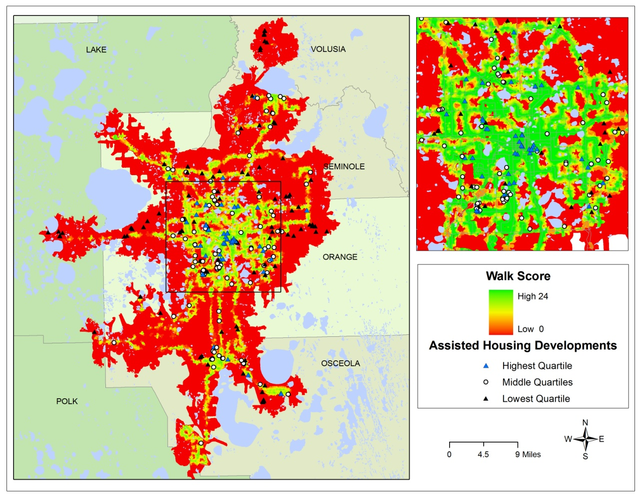
Figure 5. Walk Scores and Assisted Housing Developments

Equally if not more important than gaining access to the transit system is entering it in locations that provide access to desired destinations, which in this study are major employment centers. Thus far the analysis has shown that compared to all locations within the transit service area, households in assisted housing developments have good access to the transit system by walking. As Figure 6 shows however, accessibility from assisted housing developments to major employment centers that are within a walking distance to the transit system is poor. Although 72% of developments (or 22,727 households) have an employment access score equal or higher to the mean score for all locations in the service area; 49% of all assisted developments (or 16,578 households) are within the lowest quartile range for all scores. As Figure 6 also shows transit accessibility to major employment centers is poor for most of the service area, and specifically for assisted housing developments.
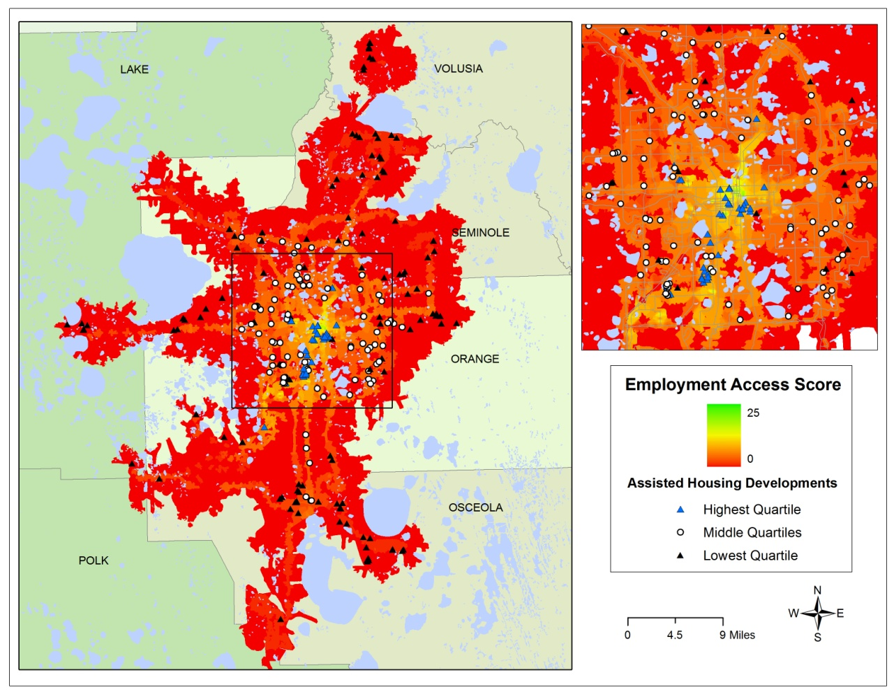
Figure 6. Employment Access Score and Assisted Housing Developments

Discussion of Implications
If good employment access can be categorized as falling within the highest quartile range of employment access scores for all locations in the transit service area, then it should be of considerable concern to providers and funders of assisted housing in Florida that only 25% of assisted housing developments in this area (or 6,470 of 32,602 households) have what might be considered good employment access via public transit. This means that 75% of assisted housing developments are located in places with relatively low access to employment using the transit system, and 28% (9,875 households) have zero walk and employment access scores.
For many of the households in the 75% of developments with low employment access, the option of taking transit to work is unrealistic because, despite having walking access to the system in most locations, opportunities to reach major employment locations are low or non-existent. The accessibility maps also show that households of all income levels are likely to experience a low rate of accessibility to employment using transit, which seems also to be borne out by journey-to-work data from the Census Bureau’s American Community Survey 2005-2009 5-year estimate showing that only 2% of workers in this region take public transit to work (US Census Bureau, 2009). However, for very low and extremely low income households with no realistic option besides a private vehicle to travel to work, the consequence of having low transit accessibility may be more dire than for higher income households; it could potentially mean the difference between being employed or unemployed.

Conclusion
Using the tool described in this paper to evaluate the transit accessibility of affordable housing developments to major employment centers in Central Florida highlighted the importance of measuring more than just proximity to transit stops. The analysis showed that while the majority of assisted housing developments in the LYNX transit service area had good accessibility to transit stops by walking, accessibility to major employment centers using the transit system was poor for 75% of them, potentially placing many very low and extremely low income households under considerable financial stress.
This outcome could be different however. By understanding the utility of transit stops in reaching employment destinations, decisions of where best to site future assisted housing developments could be improved by drawing attention to locations that are already adequately serviced or highlighting ones that could be enhanced by route and scheduling improvements. Identifying existing developments that would be difficult to improve through service enhancements would also help to “narrow the field” when prioritizing affordable housing preservation efforts. For policymakers, the tool would be helpful in reaching a balance between policies directed both at improving housing and those aiming to improve transit service.
The policy implication underscored by this paper is that more precise measures of accessibility should be incorporated into decisions concerning the location of affordable housing and employment opportunities if we hope to plan sustainable communities. The tool outlined in this paper takes a positive step in that direction by highlighting the need for practical planning tools and demonstrating how sustainable concepts such as measuring transit accessibility could be put into practice.

References
Been, V., Cunningham, M., Ellen, I.G., Gordon, G., Parilla, J., Turner, M.A., Whitney, S.V., Yowell, A., & Zimmerman, K. (2010). Building Environmentally Sustainable Communities: A Framework for Inclusivity. Retrieved from http://www.urban.org/publications/412088.html
Lei, T. L., & Church, R. L. (2010). Mapping transit-based access: Integrating GIS, routes and schedules. International Journal of Geographical Information Science, 24(2), 283-304. doi:10.1080/13658810902835404
Curtis, C., & Scheurer, J. (2010). Planning for sustainable accessibility: Developing tools to aid discussion and decision-making. Progress in Planning, 74(2), 53-106. doi:DOI: 10.1016/j.progress.2010.05.001
Florida Housing Finance Corporation. (2011). 2011 Universal Application Instructions for Multifamily Mortgage Revenue Bonds (MMRB) Program and HOME Investment Partnerships (HOME) Rental Program. Retrieved from http://www.floridahousing.org/FH-ImageWebDocs/UniversalApps/2011/ApplicationInstructionsRules/2011-10-24/2011_Universal_Application_Instructions.pdf
Handy, S. (2002). Accessibility Versus Mobility - Enhancing Strategies for Addressing Automobile Dependence in the U.S. Retrieved from http://www.des.ucdavis.edu/faculty/handy/ECMT_report.pdf
Hanson, S. (2004). The context of urban travel: Concepts and recent trends. In S. Hanson, G. Giuliano (Eds.), The Geography of Urban Transportation (3rd ed., pp.3-29). New York: The Guildford Press.
Lee, B. (2004). Parcel-level measure of public transit accessibility to destinations. Proceedings from the Access to Destination Conference. Minneapolis, MN: University of Minnesota.
Mavoa, S., Witten, K., McCreanor, T., & O’Sullivan, D. (2012). GIS based destination accessibility via public transit and walking in auckland, new zealand. Journal of Transport Geography, 20(1), 15-22. doi:10.1016/j.jtrangeo.2011.10.001
Primerano, F. & Taylor, M. (2005). Increasing accessibility to work opportunities in metropolitan Adelaide. Journal of Eastern Asia Society for Transportation Studies, 6, 4097-4112.
Shimberg Center for Housing Studies, University of Florida. (2009). The State of Florida’s Assisted Rental Housing. Retrieved from http://flhousingdata.shimberg.ufl.edu/docs/AssistedHousingReport2009.pdf
Shimberg Center for Housing Studies, University of Florida. (2012). Assisted Housing Inventory. Retrieved from http://flhousingdata.shimberg.ufl.edu/datasets.html#a_ASSTH
Tomer, A., Kneebone, E., Puentes, R., & Berube, A. (2011) Missed Opportunity: Transit and Jobs in Metropolitan America. Retrieved from http://www.brookings.edu/~/media/Files/Programs/Metro/jobs_transit/0512_jobs_transit.pdf
U.S. Census Bureau. (2005-2009). Orange, Osceola, Seminole, Volusia Counties, FL, B08301 Means of transportation to work [Data]. 2009 American Community Survey 5-Year Estimates. Retrieved from Geolytics, Inc. American Community Survey ® 2005-2009.
U.S. Department of Transportation, Federal Highway Administration. (2009) National Household Travel Survey. Retrieved from http://nhts.ornl.gov.

