Allocation and Preservation of Affordable Housing: A Spatially Discriminated Supply‐Demand Analysis Based on Parcel Level Employment Assignment

Abdulnaser Arafat (University of Florida), Yuyang Zou (University of Florida), Andres Blanco (University of Florida), Ruoniu Wang (University of Florida)
Presenter’s Email Address: naserarafat@dcp.ufl.edu

Abstract
Housing affordability has been evaluated by the Center for Neighborhood Technology (CNT) based on the combined cost of housing and transportation relative to household income. The combined housing and transportation cost usually increases as commuting distances increase. This emphasizes the importance of transportation cost that CNT included in their affordability estimation. The relationship between housing location and job location is important as well. For assisted housing, the literature suggests that access to low income jobs reduces travel cost and thus improves affordability. Therefore, more information about the housing and low-income job relationship is needed to allocate and preserve suitable land for affordable housing. This research studies assisted housing supply and demand and focuses on understanding the spatial dynamics of employment-affordable housing for low-income populations. The result shows that there is a mismatch between the suitable locations for low-income housing and existing affordable housing locations. The research also shows areas that have a balance of supply and demand, and areas with an oversupply of assisted housing, as well as places that are in need of more affordable housing units. Additionally, this research gives rise to further discussions on strategies to approach the affordable housing supply and demand analysis, as well as understanding spatial mismatch problems.
1 Introduction
CNT was the first to create the “H+T” index which estimates affordability by spatially calculating the cost of housing and transportation and relating them to household income (CNT, 2010). However, suitable locations for affordable housing also depend on other neighborhood and socio-economic characteristics that are not included directly in the CNT’s “H+T” index. The Affordable Housing Suitability model (AHS) was developed by the University of Florida to assist local communities in the allocation and preservation of affordable housing sites (AHS, 2009). In addition to the characteristics of parcels, the AHS incorporates travel cost, socio‐economic characteristics and housing cost in the allocation process.
Housing supply and demand analysis is developed in this study for incorporation into the AHS for the purpose of scoring suitable land for affordable housing. This paper will carry out two comparisons among the results of the spatial mismatch between housing and jobs by incorporating spatially discriminated multilevel supply-demand analysis. To estimate the demand for affordable housing, the new method will use a road network-based distance shed around each residential parcel to capture the parcel‐level employment. The parcel‐level employment data is generated by matching the Census Bureau’s Longitudinal Employer‐Household Dynamics (LEHD) data and data from other sources such as land use, parcels or property appraisal data. The supply will be estimated using geo‐spatial modeling based on the current locations of assisted and affordable housing. The comparison of supply and demand will allow spatial analysis of the localized needs for housing, providing valuable information for the prioritization and allocation of public resources for the provision of affordable housing.
2 Literature Review
2.1 Demand of affordable housing
A report on housing impact analysis supported by the U.S. Department of Housing and Urban Development (HUD) was drafted in 2006. Six fundamental determinants for housing demand were defined in the report and could be categorized into two aspects, household size and incomes, and the creation and location of jobs in an area (Dacquisto, 2006, p16). To determine if housing was affordable, HUD used Area Median Incomes (AMIs) which are calculated and published annually. When developers provide affordable housing, they would be likely to take more notice of the building cost and not the percentages of AMI for tenants. For home-owners, there are other factors besides direct housing cost that may have an impact on affordability, for example, indirect costs like commuting distance (Bogdon & Can, 1997). Haffner and Heylen (2011) used an “opportunity cost” to conceptually integrate the concerns of demand-side affordability from the financial perspective of home-owners and renters.
Recently, Vincent Gray, the mayor of Washington D.C. announced in the city’s new Comprehensive Housing Strategy Task Force that would change the city’s conception of its affordable housing strategy, signaling a shift that emphasizes more the demand for affordable housing than its supply (DePillis, 2012).

2.2 Supply of affordable housing
Generally, the development of affordable housing for lower income groups was carried out according to a consideration of housing prices, renovation efforts and construction costs. The American Housing Survey was the primary data source for reference. Due to the time-lag of the survey and ongoing constructions, a certain number of omissions in housing unit counts existed (Gyourko & Saiz, 2004). Desai (2008) claimed that supply-side housing policy benefited low-income families in purchasing and renting.
In Florida, funding sources vary between the Department of Housing and Urban Development (HUD), the Department of Agriculture Rural Development program (RD), and other local finance authorities, such as Florida Housing Finance Corporation (FHFC) and Local Housing Finance Authorities (LHFAs). The Shimberg Center for Housing Studies maintains an Assisted Housing Inventory (AHI) for the purpose of providing relevant data on lower income tenants and housing owners. According to Shimberg Center research, the majority of assisted housing units (92%) serve tenants whose income was at or below 60% of the Area Median Income (AMI). The target population in this study can be categorized as having very low income (equal or less than 30% AMI) to moderately low income (50% to 80% AMI) according to affordability ranges provided by HUD. The target population was categorized into two groups, those with very low income (VLI) equal to or less than 30% of AMI, and those with low income (LI) of 30% to 80% of AMI.

2.3 The mismatch of supply and demand
To discuss the spatial mismatch of housing and jobs from the perspective of the low-income employment population, there are several factors for consideration, such as commuting costs that are too high compared to wages, insufficient information, and the cost of searching for jobs from distant residential locations (Gobillon, Selod, & Zenou, 2007). Because of constrained mobility, low-income workers can experience difficulty in finding affordable housing near locations with employment opportunities. These groups may have difficulty affording high commuting costs if they live in distant suburban locations where there is a lack of sufficient public transportation and employment.
Measuring urban spatial mismatch using job-housing indicators for modeling and analysis has been supported by more and more researchers and planners. In research by Horner and Mefford (2007), modeling was developed based on a review of the job-housing literature and used to explore the mismatch between certain groups of people with different backgrounds. Through a comparison of the extent of spatial mismatch, planners could better understand which areas of housing were more suitable for target populations in lower income groups.
3 Study area and Data
In this research, Orange County in Florida is selected as the case study. The following points explain the data used in the study as well as data sources.
3.1 Property Parcels
This study utilized 2009 property parcel and tax payer data for Orange County derived from the Florida Department of Revenue and retrieved from the Florida Geographic Data Library (FGDL). The data is in a geographic information system (GIS) format which outlines the boundary of parcels in the county and lists property tax roll data for each parcel as well as owner addresses, the year properties were built, and property just-values.
3.2 Longitudinal Employer‐Household Dynamics (LEHD)
Quarterly Workforce Indicators (QWI) as of 2009, derived from the LED partnership, US Census data were used in the study.
3.3 Census block
Census data consisting of Topological Integrated Geographic Encoding Referencing (TIGER) line files were used in the study. The data delineates the geographic boundaries of census units, and includes tables listing the aggregation of population and housing for the U.S. every ten years. The 2000 census data was used in this study.
3.4 Assisted Housing Inventory (AHI) for 2010 from the Shimberg Center for Housing Studies database.
3.5 Road and Network data for 2009 obtained from the Florida Geographic Data Library (FGDL).
4 Methodology
4.1 Mapping parcel-level employment
The methodology for determining parcel-level employment played an important role in this study, especially in the incorporation of socio-economic characteristics from the census data at a parcel-level scale. QWI data were divided into two groups by North American Industry Classification System (NAICS) sectors of land area and living area. After summarizing the total areas by census block and land use, the density of employees by industrial sector was calculated for each block. Block group-level employee densities by industrial sector were then assigned to property parcels using multipliers from a cross-tabulation methodology.
4.2 Origin-Destination (OD) cost matrix analysis
The Network Analyst tool in ArcGIS 10 provides this advanced analysis matrix. The OD cost matrix finds and measures the least-cost paths along the network from multiple origins to multiple destinations. When configuring an OD cost matrix analysis, the number of destinations to be found can be specified and a maximum distance to search can be set.
Five thousand random points were created in the county in this study. These random points are the focal points in later steps of the analysis. To accomplish further geo-statistical analyses, the primary procedure was to use a moving window analysis method by creating a tool to identify a certain network distance buffer from each focal point as shown in Figure 4-1. Three network distance buffers were applied, based on three different travel modes. In this study, a distance of 0.5 mile was considered a walking distance, 4 miles was a biking distance, and 10 miles was a driving distance.

4.4 Comparison of the number of employees and units of AHI based on county averages
As shown in Figure 4-2, according to the parcel-level data the number of employment opportunities can be captured in each network distance buffer area of the random points. This represents the demand-side need for affordable housing. The supply-side of housing can be captured in the area according to the information provided by the AHI data or tax parcel data for multi-family properties. The estimates of housing supply and demand are assigned to the corresponding random points. The same analysis is prepared for all the random points.
In this study, the target population was divided into two groups. One was the very low-income population, who are people with annual incomes below 30% AMI. The other was the low-income population, who were people with annual incomes between 30% AMI and 80% AMI. After assigning both demand and supply values to the corresponding random points, raster data layers were generated by inverse distance weighted (IDW) interpolation to create a surface that predicts the supply and demand in the surrounding specified network service area of any location in the county.
The network service area in this research corresponds to the walking, biking and driving distances. To better compare the results, a common and widespread statistical method was employed to standardize all the data on one scale using a z-score. Each z-score corresponds to a point in a normal distribution. A z-score describes how much a point deviates from a mean value and it is calculated by subtracting the mean value from the original estimated value and then dividing the result by the standard deviation. The mean and standard deviation are estimated for the whole raster which represents the total number of points in the study area. In this way, a concise and explicit comparison by z-score could be carried out easily.
4.6 Mapping the spatial mismatch.
The z-score comparison shows the relative opportunity values in the number of standard deviations for the points in the data’s distribution. It also allows for a comparison of scores obtained for different locations and to map the mismatch. In summary, the map of z- scores shows the comparative scores for demand and supply, and places where there is a balance between supply and demand, as well as places that have affordable housing oversupply or places that are in need of more affordable housing units.
The conceptual relationship between the supply and demand of affordable housing is shown in the Figure 4-3. To understand the spatial mismatch, two comparisons were carried out in this study. One is the comparison between the location of multi-family housing units and AHI housing units. The other is the comparison among the AHI dataset by categorizing it into different groups by funding sources. These groups are HUD/ RD- funded properties and LHFA/ FHFC-funded properties.
A conflict analysis procedure is also adopted in this paper to identify spatially the balance between supply and demand as well as places of opportunity that have more supply than demand. The Land Use Conflict Identification Strategy (LUCIS) (Carr & Zwick, 2007) uses suitability matrices to identify the conflict between agricultural, conservation and urban land uses. Similar matrices are used in this paper to analyze the spatial conflict between relative concentrations of supply and demand compared to county averages.
5 Analysis and Results
The 4-mile network distance buffer was used as an example for the analysis in this paper. The same procedure was also used for the walking and driving distances. After generating random points for Orange County, Florida, a 4-mile network distance buffer area was created for each of the 5,000 points based on the OD matrix methodology. Within each 4-mile service area, all the employment opportunities and affordable housing units were captured. Using the OD matrix, all the distances from housing units to the employment opportunities was calculated. After estimating all the distance values, they are assigned to the corresponding random points, and raster surfaces were created for both supply-side affordable housing from housing data, and demand-side affordable housing from employment data. For the further analysis, these raster data were transferred to their z-scores. The GIS maps shown in Appendix A show the 4-mile biking distance buffers as the examples.
Figure 5-1 shows the reclassified z-score mapping for each of the supply-side affordable housing raster. The analyses for supply-side housing were for multi-family housing units, AHI housing units, HUD/RD funded housing units, and FHFC/LHFA funded housing units. The latter two data were from AHI data but separated according to the criteria of different funding sources. The maps in Figure 5-1 show areas shaded in light grey representing where opportunity for housing units was equal or greater than the average opportunity for affordable housing units for the county as a whole. These areas are where z-scores are greater or equal to zero. Conversely, where z-scores were less than zero, areas had less than average opportunities for affordable housing units, and are shaded on the map in dark grey.
The supply-side raster grids are used in a comparison with demand-side raster grids created from employment data to see the spatial mismatch between them. In each comparison, there were two outputs according to the two levels of income, the very low-income (VLI) and the low-income (LI). Figures 5-2 through 5.5 show the mismatch between the existing housing units, which were supplied for VLI and LI populations, and the need for housing units for those populations.
The analysis was repeated for the 0.5-mile walking distance network and 10-mile driving distance buffers.
Tables were generated summarizing the comparisons, as shown in Appendix B. All the scores for the percentage of mismatch in the tables were obtained by comparing to average opportunity value and where they were equal or above the average.
5.1 Comparison I: Mismatch between Housing Units of Multifamily and AHI
As shown in Figure 5-6, the overall spatial mismatch of each type of housing units diminishes as distances increase. Among the three network buffer distance analysis results, the largest mismatch lies in the 0.5-mile walking distance buffer which was more than twice the percentage of mismatch for either the 4-mile biking distance or the 10-mile driving distance. The increased mismatch is not as significant when the distance decreases from 10 miles to 4 miles. According to the results shown in Table 5-1, the mismatch based on the 0.5-mile walking distance buffer shows that the AHI housing units have a larger percentage of spatial mismatch, and that the mismatch of both VLI and LI housing units locations reaches to approximately 85% over the housing supply and demand. The variation for the employment mismatch for multi-family housing units was also low but in favor of the multi-family location where the mismatch is a little bit lower than the employment mismatch for the AHI units.
5.2 Comparison II: Mismatch between HUD funded housing units and FHFC/LHFA funded housing units
Both HUD funded and FHFC/LHFA funded housing units data were derived from AHI data. This applied comparison will highlight how well these funding sources have provided affordable housing for lower income populations. .
In Figure 5-7, HUD/RD funded housing units showed a steady decrease in the percentage of mismatch with an increase in network distance to employment, indicating that these housing units consistently received a similar level of the disproportion over supply and demand. Among the FHFC/LHFA funded units, the mismatch shows a substantial decrease when the network distance increased, but not for distances exceeding 4 miles. This suggests that most of affordable housing units funded by FHFC/LHFA are located beyond the walking distance to employment but are better located than HUD/RD properties in terms of biking distances.
As shown in Table 5-2, both the percentage of mismatch for HUD/RD funded units and FHFC/LHFA funded units reaches to around 90%, which is consistent with the assumption that very small amounts of these affordable housing units are within the walking distance to employment. When the distance is increased to a 4-mile biking distance, the difference varies in that the mismatch was still above 50% for HUD funded housing units, while it falls to 40% of mismatch for FHFC/LHFA funded housing units. For either funding source, the mismatch of housing units showed larger percentages for VLI populations than for LI populations.
5.3 Spatial identification of oversupply
The spatial mismatch maps show the location of matching and mismatching between the supply and demand for affordable housing units. The maps in Figures 5.2 through 5.5 do not show if the mismatch locations have more supply or more demand. Figures 5.8 and 5.9 show the supply-demand balance, the location of areas of oversupply, and areas that are still in need of affordable housing units. These maps can help housing finance agencies in the allocation of new affordable housing units. The maps can also show the places that have an oversupply when compared to county averages. However, further studies are needed for the explanation of why these places are attractive to low income population.
6 Conclusions and Discussions
In this study, the comparison of mismatch of locations between multi-family and AHI housing units indicates that the majority of properties in either multi-family or AHI are located in places that have a large number of low-income job opportunities within biking and driving distances. Within these two types of housing units, and by comparing the units with county averages in terms of housing supply and demand, there is a slight difference in supply-demand balance. Low income population demand shows fewer mismatches with supply than the very low income population demand. In accordance with different funding sources for the affordable housing units, in general, the FHFC/LHFA funded housing units were much better in terms of their supply-demand balance for lower income populations than HUD funded housing units. For the latter properties, low income population demand still had fewer mismatches with supply than for the very low income population demand.
One cannot ignore the problems of existing living situations of lower income populations in the city. Firstly, the total amount of affordable housing units is limited, meaning that only a small percentage of the low income population has access to affordable housing in the city. Secondly, to diminish the cost of affordable housing supply, affordable housing was mostly built where the land prices were relatively cheap. Therefore, the edge of the city or suburbs would be better places for new construction. However, these locations could not meet the lower income population needs. In that case, the question of how to provide a reasonable distribution of affordable housing and reduce the lower income populations’ indirect costs becomes a focus for social concern. The affordable housing problems of low income people are not their individual problems. It is related to all classes of society including those with middle and high-incomes. The indirect cost of housing is usually ignored by housing developers. This research provides tools that can be used by the housing finance corporations to evaluate the locations of funded properties as well as evaluating the suitability of new sites suggested by developers. The conflict analysis used in this paper shows clearly where places have a balance in the supply and demand, and places that need more affordable housing units. It also shows places that have an oversupply of units and that may need other solutions for improving employment opportunities that could be implemented by local governments. In addition to the tools for planners and housing finance agencies, the analysis of this study raises further questions and discussions to be solved in future research. These questions include studying the spatial mismatch for affordable rental housing and more comprehensive supply demand analysis.
APPENDIX A: FIGURES
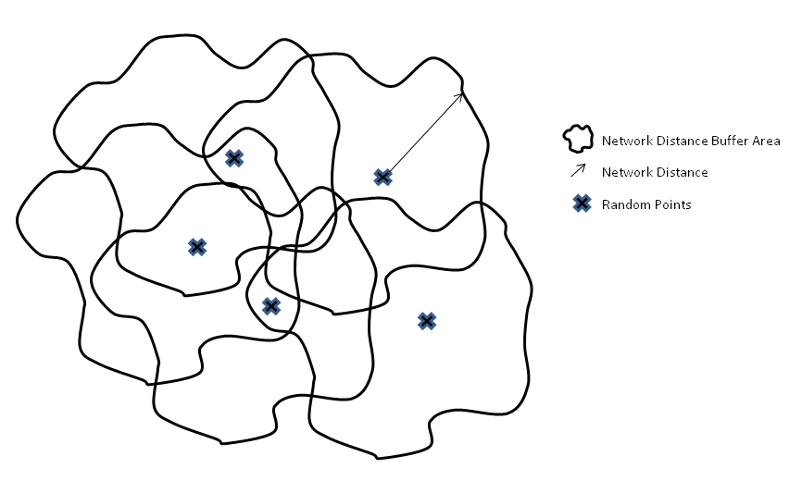
Figure4-1 Network distance buffer on random points

Figure4-2 Capture the features in each network distance buffer area

Figure4-3 Sketch map for the relationship of supply and demand of affordable housing

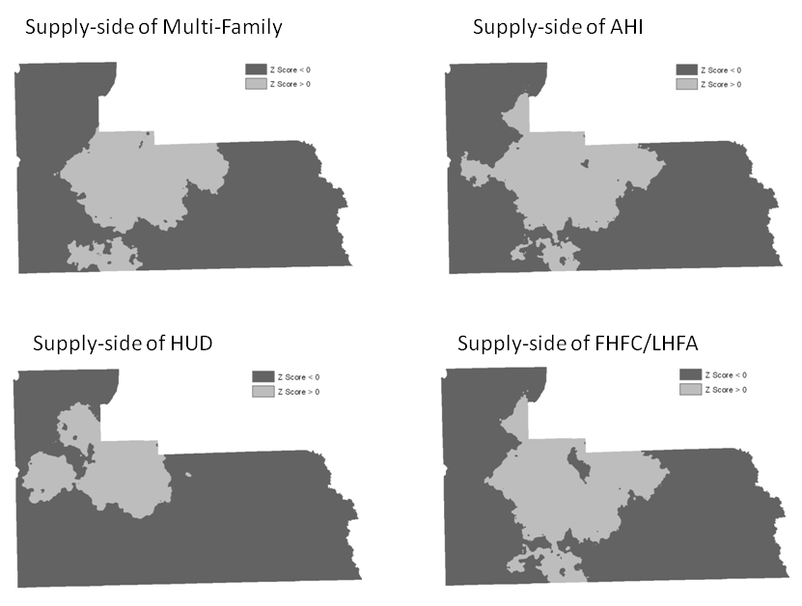
Figure5-1 Z-score maps for four types of affordable housing supply
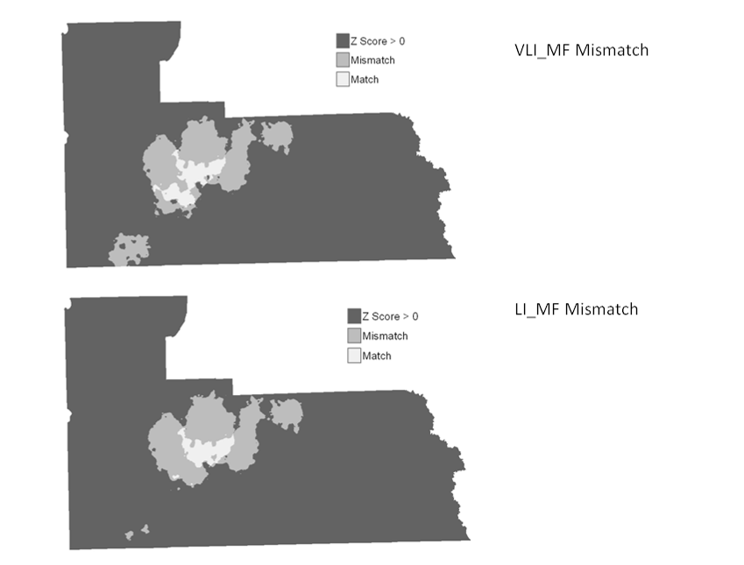
Figure 5-2 Mismatch between multi-family housing units and affordable housing need for VLI and LI population

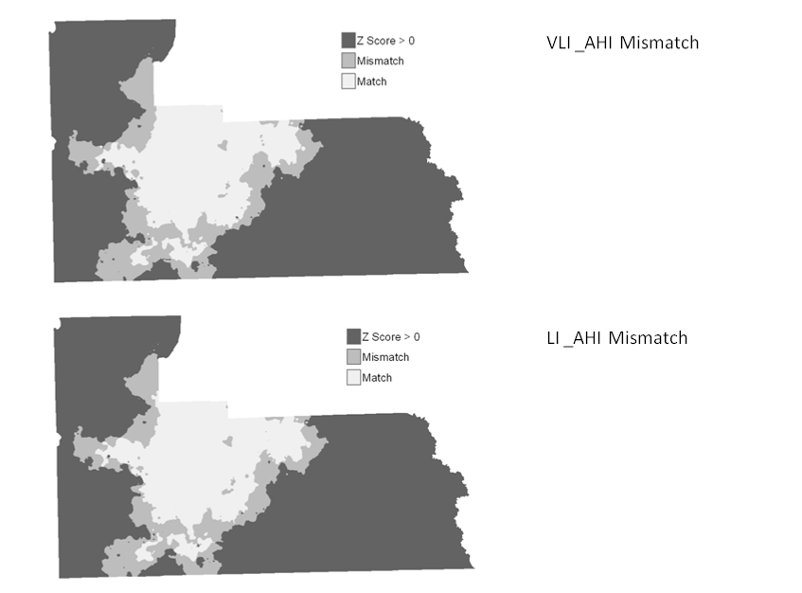
Figure 5-3 Mismatch between AHI housing units and affordable housing need for VLI and LI population
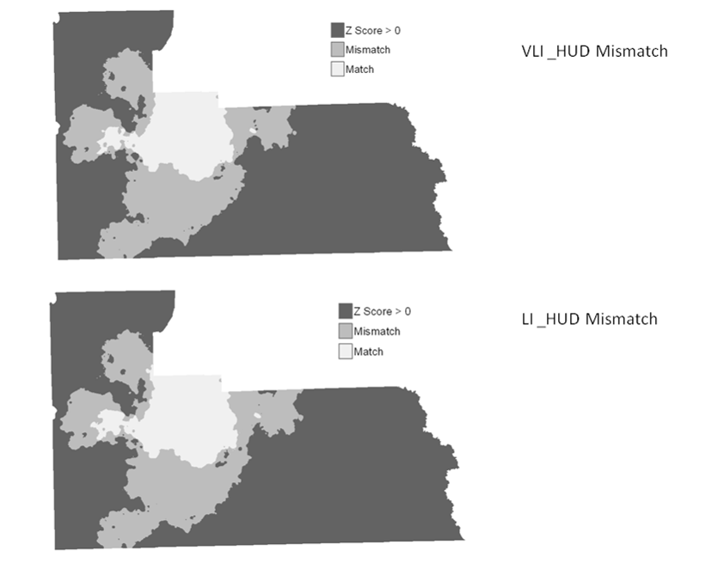
Figure5-4 Mismatch between HUD funded housing units and affordable housing need for VLI and LI population
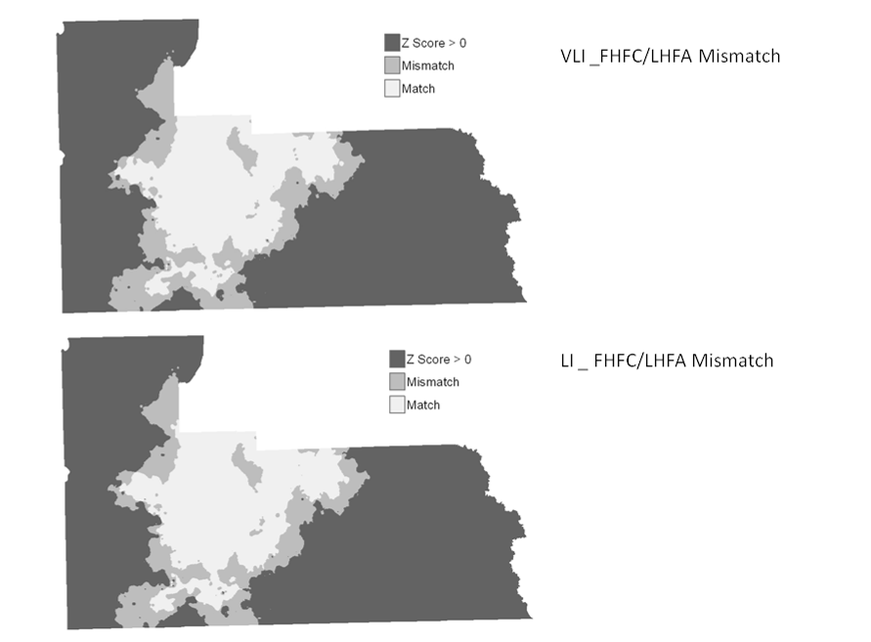
Figure5-5 Mismatch between FHFC/LHFA funded housing units and affordable housing need for VLI and LI population

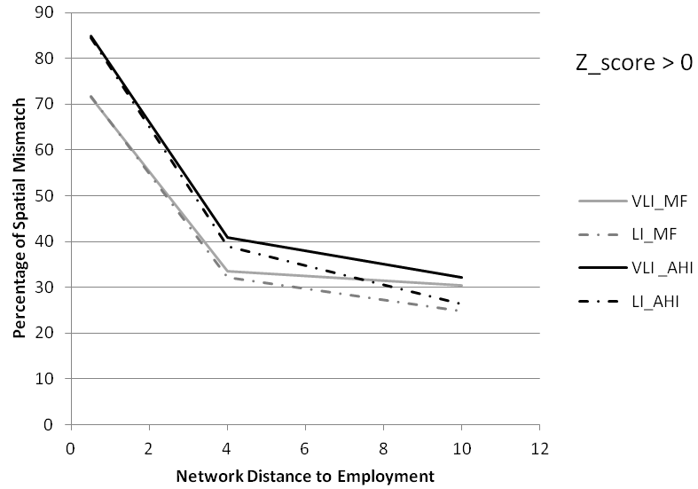
Figure5-6 Employment Spatial Mismatch for Assisted and Multifamily Units

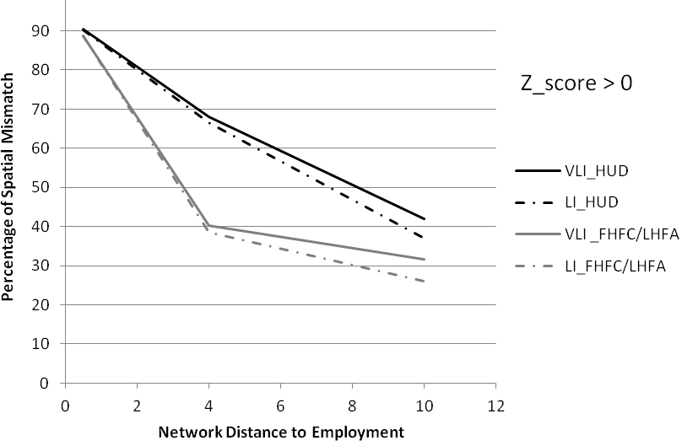
Figure5-7 Employment Spatial Mismatch for Assisted Units by Funding Sources

Figure 5-8 Supply Demand Balance – Multi Family and Assisted Housing Properties

Figure 5-9 Supply Demand Balance – HUD and FHFC Properties
APPENDIX B: TABLES
Table5-1 Percentage of the Supply Demand Mismatch For Multifamily and Assisted Housing Units
 | MORE THAN AVERAGE
DISTANCE (Mile) | MULTIFAMILY MISMATCH |  | AHI MISMATCH
 | VLI_MF | LI_MF | VLI _AHI | LI_AHI
0.5 | 71.48 | 71.73 | 84.84 | 84.56
4 | 33.48 | 32.09 | 40.84 | 38.88
10 | 30.49 | 24.76 | 32.12 | 26.41

Table5-2 Percentage of the Supply Demand Mismatch For the Assisted Housing Units by Funding Sources

 | MORE THAN AVARAGE
DISTANCE (Mile) | HUD_ MISMATCH |  | FHFC/LHFA MISMATCH
 | VLI_MF | LI_MF | VLI _AHI | LI_AHI
0.5 | 90.42 | 90.18 | 88.82 | 88.65
4 | 68.06 | 66.62 | 40.25 | 38.59
10 | 42.03 | 36.94 | 31.68 | 26.13

References
Bogdon, A. S., & Can, A. (1997). Indicators of local housing affordability: Comparative
and spatial approaches. Real Estate Economics, 25(1), 43-80.
Carr M., & Zwick. P. (2007). Smart land-use analysis: The LUCIS model. Redlands, CA:
ESRI press.
Center for Neigborhood Technology CNT (2010). True affordability and location
efficiency. Retrieved January 30, 2011, from http://htaindex.cnt.org/
Dacquisto, D. J., &Rodda, D. T. (2006, January). Housing Impact Analysis. Available:
http://www.huduser.org/Publications/pdf/hsgimpact.pdf (2011, November 15 )
DePillis, L. (2012,Febuary). Gray Signals Shift to “Demand Side” On Affordable
Housing. Available: http://www.washingtoncitypaper.com/blogs/housingcomplex/2012/02/22/mayor-gray-signals-shift-to-demand-side-on-affordable-housing/ (2012, March 1)
Desai, M. (2008, March). Investable Tax Credits: The Case of the Low Income Housing
Tax Credit. Available : http://www.nber.org/public_html/confer/2008/tep08/desai.pdf (2012, Febuary 2)
Florida Affordable Housing Model (2009). Affordable housing model methodology.
University of Florida: Department of Urban and Regional Planning.
Gobillon, L., Selod, H., & Zenou, Y. (2007). The mechanisms of spatial mismatch. Urban Studies, 44(12), 2401-2427.
Gyourko, J., & Saiz, A. (2004). Reinvestment in the housing stock: the role of construction costs and the supply side. Journal of Urban Economics, 55(2), 238-256.
Haffner, M., & Heylen, K. (2011). User Costs and Housing Expenses. Towards a more Comprehensive Approach to Affordability. Housing Studies, 26(4), 593-614.
Horner, M. W., & Mefford, J. N. (2007). Investigating urban spatial mismatch using job-housing indicators to model home-work separation. Environment and Planning A, 39(6), 1420-1440.
Ray, A., Nguyen, D., O’Dell, W., Roset-Zuppa, P., &White, D. (2009, June).The state of
Florida's assisted rental housing. Available: http://www.policyarchive.org/handle/10207/bitstreams/20727.pdf (2012, February 8)

